Microsoft Cloud Workshops

Microservices and Serverless Architecture Hackathon

Lab Guide

February 2017

© 2017 Microsoft Corporation. All rights reserved. This document is confidential and proprietary to Microsoft. Internal use only. This document is for informational purposes only. MICROSOFT MAKES NO WARRANTIES, EXPRESS OR IMPLIED, IN THIS SUMMARY.

This document is provided "as-is." Information and views expressed in this document, including URL and other Internet Web site references, may change without notice. You bear the risk of using it.

Some examples are for illustration only and are fictitious. No real association is intended or inferred.

## Contents

Azure Resource Map 1

Microservices and Serverless Architecture Hackathon 2

Microservices and Serverless Architecture Hackathon answers 26

# Azure Resource Map

The following figures are intended to help you keep track of all the technologies and endpoints you are working with in this hackathon. The first figure is the overall architecture, indicating the Azure resources to be employed. The second figure is a more detailed picture of the key items you will want to remember about those resources as you move through the exercises.

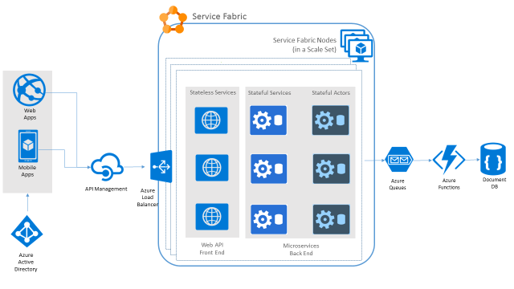

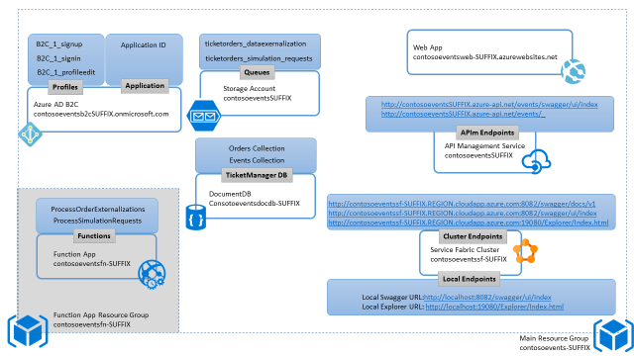

# Microservices and Serverless Architecture Hackathon

## Overview

Contoso Events is an online service for concerts, sporting and other event ticket sales. They are redesigning their solution for scale with a microservices strategy and want to implement a POC for the path that receives the most traffic: ticket ordering.

In this hackathon, you will construct and load test an end-to-end POC for ticket ordering. You will leverage Service Fabric, API Management, Function Apps, Web Apps, Document DB, and Azure Active Directory B2C. You can do a few BONUS exercises if you still have time after running through the primary exercises.

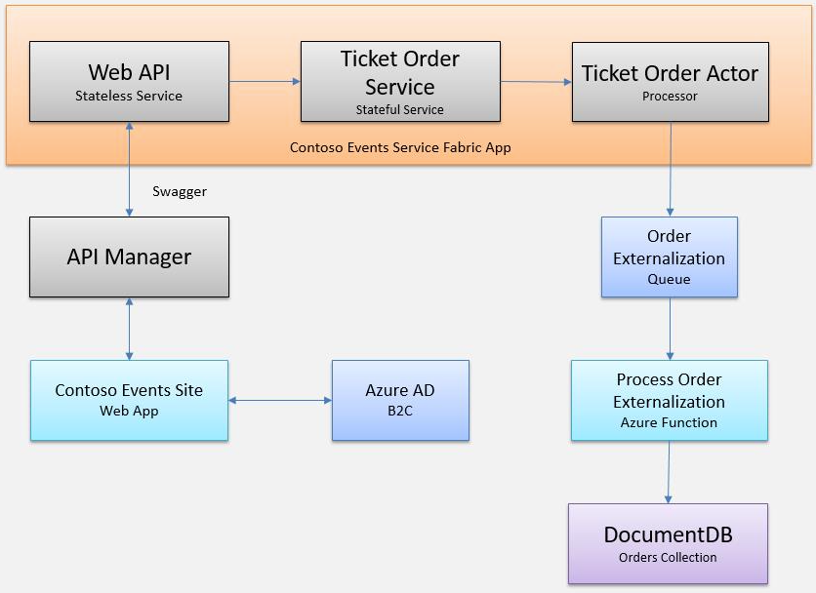

**IMPORTANT: Most Azure resources require unique names. Throughout these steps, you will see the word “SUFFIX” as part of resource names. You should replace this with your Microsoft alias or other username to ensure the resource is uniquely named.**

## Requirements

* Microsoft Azure subscription must be pay-as-you-go or MSDN.
  + Trial subscriptions will *not* work.
* Local machine or a virtual machine configured with:
  + Visual Studio 2015 with Update 3 or later
  + [Azure SDK 2.9.1 or later for Visual Studio 2015](https://azure.microsoft.com/en-us/downloads/)
  + [Service Fabric SDK 2.4.145 (with Runtime 5.4.145)](https://docs.microsoft.com/en-us/azure/service-fabric/service-fabric-get-started) for use with Visual Studio 2015
  + Azure PowerShell 1.0.0 or later
  + A browser such as Edge, Chrome, or Firefox (IE does not work with Swagger commands)

## Exercise 0: Before the Hackathon

Duration: 15 minutes (plus up to 30 minutes or more provisioning time)

You should follow all of the steps provided in Exercise 0 *before* attending the Hackathon.

**If you forget to do this before the hackathon, you should proceed to Exercise 1 before the service fabric cluster completes in Task 2 of this section, so that you do not lose time.**

### Task 1: Resource Group

You will create an Azure Resource Group to hold all items created in this exercise. This approach will make it easier to clean up later. Because you will want to include the Service Fabric Cluster that you create in the same Resource Group as other resources you create during the remaining exercises, you will create the Resource Group now.

**Note**: This Resource Group will be used for all resources you create with one exception, for the Function App. This document will refer to this Resource Group as the “resource group you created previously” because it is the primary Resource Group.

#### Tasks to complete

* Create a new Azure Resource Group. Name it something like “contosoevents-SUFFIX”. Choose a region you will also use for future steps so that resources you create in Azure are all kept within the same region.

#### Exit criteria

* Your Resource Group is listed in the Azure Portal.

### Task 2: Service Fabric

In this section, you will provision the Service Fabric Cluster.

#### Tasks to complete

* Create a new Service Fabric Cluster in the resource group you just created. Choose the same region you will use for all resources.
* Leave the cluster defaults and configure the node type with a Standard_D1_v2 machine size and provide 8082 as a Custom endpoint.
* In the interest of time during this hackathon, only you will set the cluster security mode to Unsecure.

#### Exit criteria

* It can take up to 30 minutes or more before your Service Fabric cluster is listed in the Azure Portal.
* **Note**: If you experience errors related to lack of available cores, you may have to delete some other compute resources or request additional cores be added to your subscription and then try this again.

### Task 3: Validate Service Fabric ports

In this section, you will validate that the new Service Fabric Cluster has the ports that you requested available – because this function fails occasionally when you provision with the portal.

#### Tasks to complete

* Navigate to the Resource Group you created previously, and where you created the cluster. If it is still deploying, do not proceed to the next step until deploying is completed.
* Select the load balancer and review the probes. Verify that there is a probe for port 8082 with TCP protocol. Verify that this probe is also in use by a load-balancer rule. If not, proceed to create them.
* If this probe is not present, create a new probe for port 8082 using TCP protocol. Then create a rule that is associated with this probe.
* If you get an error notification such as “Failure to create probe”, ignore this but just go check that the probe indeed exists. It should.

#### Exit criteria

You will now have a cluster ready to deploy to and expose 8082 as the Web API endpoint / port.

## Exercise 1: Environment setup

Duration: 30 minutes

Contoso Events has provided a starter solution for you. They have asked you to use this solution as the starting point for creating the Ticket Order POC solution with Service Fabric.

Because this is a “born in Azure” solution, it depends on many Azure resources. You will be guided through creating those resources before you work with the solution in earnest. The following figure illustrates the resource groups and resources you will create in this exercise.

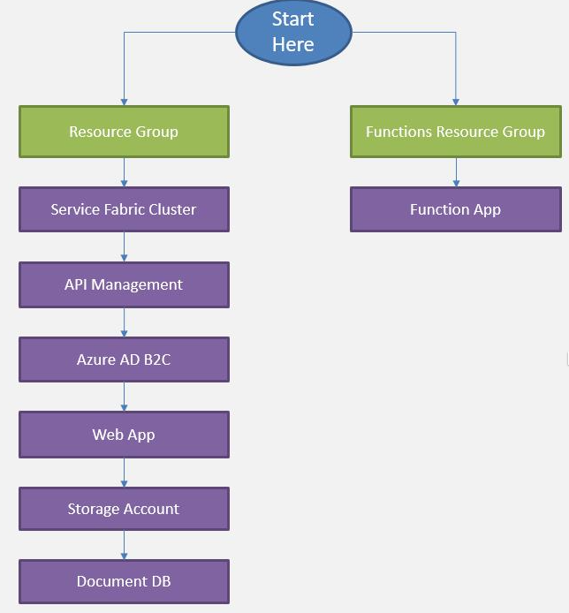

### Task 1: Download and open the ContosoEventsPoc Starter

1. Download the starter project from the following URL: <http://bit.ly/2jyZqbd>
2. Unzip the contents.
3. Open ContosoEventsPoc.sln with Visual Studio.
4. Before you compile the solution set the configuration to x64.

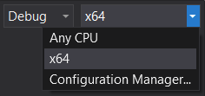

**Note**: If you have the prerequisites on your VM, this solution should open without requesting additional software to be installed. You should also be able to compile without error, but the solution is not yet ready to run.

1. Make sure you can compile.

### Task 2: API Management

In this section, you will provision a new API Management service.

#### Tasks to complete

* Create a new API Management service with a URL like contosoeventsSUFFIX, in the same region you used previously. Use Developer pricing tier.

#### Exit criteria

* After the service is provisioned, it will be listed in the API management list in the Portal. This may take up to 10-15 minutes, so move to Task 3 and return later to verify.

### Task 3: Azure Active Directory B2C

In this section, you will provision an Azure Active Directory B2C tenant. You will use this if you do BONUS Exercise 10 so it is best to set it up in advance to avoid having to wait for provisioning.

#### Tasks to complete

* Create a new Azure Active Directory B2C tenant in the same region as your other items. Use the domain “contosoeventsb2cSUFFIX”. Set it up as a B2C directory.
* Configure the tenant for Username sign in.
* Create three profiles: sign in, sign up, and profile edit.

#### Exit criteria

* After the tenant is provisioned, it will be displayed in the Active Directory list in the Management Portal. This may take up to 5 minutes, so move to Task 4 and return later to verify.

### Task 4: Web App

In these steps, you will provision a Web App in a new App Service Plan.

#### Tasks to complete

* Provision a Web App to host the website. Create an App Service Plan in the Resource Group and region you used previously. Name the Web App something like “contosoeventsweb-SUFFIX”.
* Select pricing tier S1 Standard.

#### Exit criteria

You can navigate to your new Web App at the URL you noted earlier based on your Web App name such as <https://contosoeventsweb-SUFFIX.azurewebsites.net>. You should see an empty website.

### Task 5: Function App

In these steps, you will provision a Function App within in a Dynamic App Service Plan.

**Note**: Functions are able to dynamically scale if you use a Dynamic App Service Plan. At this time, you cannot select a pre-existing Resource Group and select this type of plan – so in this section you will create a second Resource Group intentionally, as a workaround.

#### Tasks to complete

* Provision a Function App to host the functions in the Visual Studio solution, in a Dynamic App Service Plan. Create a new Resource Group with a name similar to your main Resource Group such as “contosoeventsfn-SUFFIX”.
* Name the App something like “contosoeventsfn-SUFFIX”.

#### Exit criteria

* When the provisioning completes, your Web App and Function App are listed in the Azure Portal.

### Task 6: Storage account

In this section, you will create a Storage account for the application to create and use queues that are required by the solution.

#### Tasks to complete

* Provision a Resource Manager based Storage account of type Standard LRS in the same Location and Resource Group as your other services.
* Name it something like ‘contosoeventsSUFFIX’.

#### Exit criteria

* After provisioning is complete, the Storage account will be listed in the Azure Portal.

### Task 7: DocumentDB

In this section, you will provision a DocumentDB account, a DocumentDB Database and a DocumentDB collection that will be used to collect ticket orders.

#### Tasks to complete

* Provision a new DocumentDB account in the same region and Resource Group as your other services. Use the name ‘contosoeventsdocdb-SUFFIX’.
* Add a database with ID ‘TicketManager’.
* Add two collections named ‘Orders’ and ‘Events’.

#### Exit criteria

* You will be able to see the two collections in the new database.

## Exercise 2: Placing ticket orders

Duration: 30 minutes

The agreed upon design with Contoso Events involves queuing ticket orders and executing them asynchronously. A stateless Web API service receives each request and queues it to a stateful service. An actor processes the request and persists the order in its state.

The design also calls for saving the state of the ticket order to a DocumentDB collection for ad hoc queries. This exercise will walk you through adding configurations that will light up the actor code that externalizes its state to a storage queue. In addition, you will set up the Function App to read from the queue and persist the order to the Orders collection of the DocumentDB instance you created.

**Note**: The code to write to the storage queue is already in place within the actor, so setting up configuration keys is the only requirement to lighting up that feature.

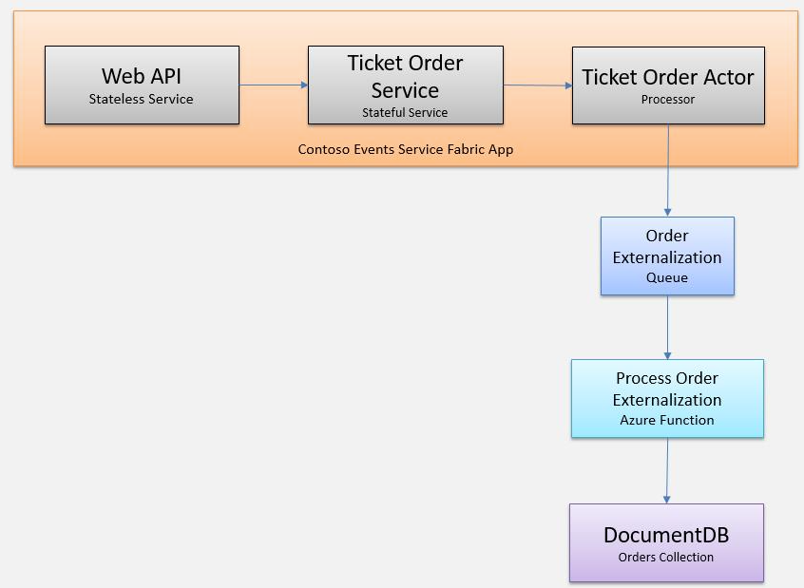

### Task 1: Run the solution

The purpose of this task is to make sure that the source code compiles and that you are able to publish to a local cluster. To make sure that the app is running flawlessly, you will run some API tests and access the Service Fabric explorer.

**Note**: Not all features are in place but you will be able to see that the application can run.

#### Tasks to complete

* First, make sure the local Service Fabric environment is running. If not, set up the local cluster.
* From Visual Studio, compile the solution and publish ContosoEventsApp to the local Service Fabric cluster.

#### Exit criteria

* In Visual Studio view the publish status. After it shows that it succeeded, the application is ready to be used.

### Task 2: Test the application

The Service Fabric Application includes a front-end Web API as the public-facing window to internal stateful services. In this task, you will check that you can call the Web API now that you have the application published to the local cluster. Because the app is not yet fully configured, not all Web API methods will be fully functional.

#### Tasks to complete

* Browse to the Swagger endpoint for the Web API at:

<http://localhost:8082/swagger/ui/index>

* Select the Admin API and select the method /api/admin/partitions. This returns the number of tickets queued across all partitions.

#### Exit criteria

* If you were able to view the Swagger definition and select the partitions method with a successful response, your environment is in a good state to continue.

### Task 3: Service Fabric Explorer

In this task, you will browse to the Service Fabric Explorer and view the local cluster.

#### Tasks to complete

* Browse to the Service Fabric Explorer for the local cluster at: <http://localhost:19080/Explorer/index.html>
* Observe the services deployed with the application.

#### Exit criteria

* If you are able to access the Service Fabric Explorer your environment is in a good state to continue.

### Task 4: Set up the Ticket Order Sync queue

The purpose of this task is to complete features of the Contoso Events POC so that placing an order also synchronizes with the back end data store. You will also update the configuration settings to reference the Azure resources you previously created correctly.

#### Tasks to complete

* Update Local.xml in the ApplicationParameters folder with your own configuration parameters for the following items:

<Parameter Name="DataStorageEndpointUri" Value="" />

<Parameter Name="DataStoragePrimaryKey" Value="" />

<Parameter Name="StorageConnectionString" Value="" />

* Set DataStorageEndpointUri to the DocumentDB endpoint Uri.
* Set DataStoragePrimaryKey to the DocumentDB Primary Key.
* Set StorageConnectionString to the connection for your storage account in this format:

DefaultEndpointsProtocol=https;AccountName=ACCOUNTNAME;AccountKey=KEY1

* Rebuild and publish the application to the local cluster.
* Browse to the local Swagger endpoint and test the POST /api/orders method by posting the following JSON formatted order payload:

{

"UserName": "johnsmith",

"Email": "john.smith@gmail.com",

"EventId": "EVENT1-ID-00001",

"PaymentProcessorTokenId": "YYYTT6565661652612516125",

"Tickets": 3

}

#### Exit criteria

* In Visual Studio, open the Cloud Explorer, navigate to the externalization queue, and verify that the new order is in the queue.

### Task 5: Set up Azure Functions

The purpose of this task is to create a function that will be triggered by the externalization queue we created for the app. Each order that is deposited to the queue by the TicketOrderActor type will trigger the TicketOrderProcessing function. The function then persists the order to the Orders collection of the DocumentDB instance.

In this task, you will also create a second function that will be used to generate load against the system at runtime. Overall, the ContosoEvents app has the following queue and function architecture that should help visualize how the queues and functions are related:

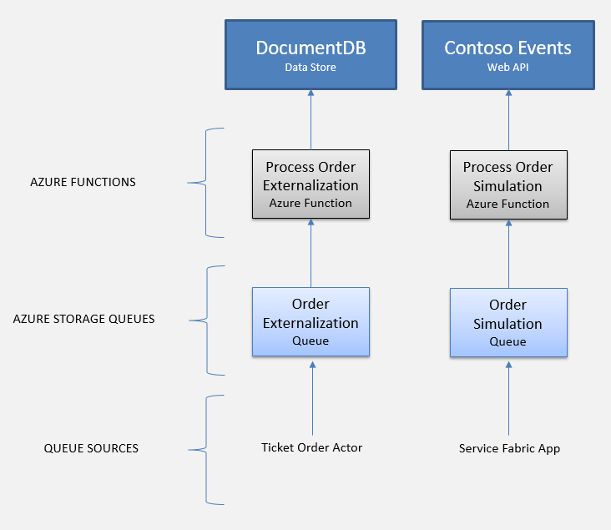

#### Tasks to complete

* From the Azure Portal, find the Function App you created previously.
* Create a function called ‘ProcessOrderExternalizations’ based on the QueueTrigger C# template. Select the queue contosoevents-externalization-requests. Connect it to the Storage account created previously.
* Select Azure Storage Queue as the trigger and select the queue name contosevents-externalization-requests.
* Connect the output to the Orders collection of the DocumentDB instance you created previously.
* Copy the code from the ProcessTicketOrderExternalizationEvent.cs file in the solution.
* Create the ProcessSimulationRequests function from the QueueTrigger PowerShell template. Name the queue contosevents-simulation-requests.
* There is no need to connect this function to an output. Copy the code from the ProcessOrderTicketSimulationRequest.PS1 file in the solution.
* You will set up the API Management key in a later step when we use this function.

#### Exit criteria

* If each function successfully compiled as you went through these steps, you are ready to proceed to the next exercise.

### Task 6: Test order data sync

In this task, you will test the ticket order processing back end to validate that orders are queued and processed by the TicketOrderProcessing function – ultimately saving the order to the Orders collection of the DocumentDB instance.

#### Tasks to complete

* Open the logs for the ProcessOrderExternalizations function.
* Process an order following your steps on Task 4. Note the order id that appears in the logs.
* From the Azure Portal, navigate to your DocumentDB account and use query explorer to query the Orders collection for the order id.

#### Exit criteria

* If the DocumentDB query returns the order id specified, the order has been fully processed through to the DocumentDB.

## Exercise 3: Publish the Service Fabric application

Duration: 15 minutes

In this exercise, you will publish the Service Fabric application to the Azure cluster you created previously. After it is deployed, you will validate it by sending orders through the Web API endpoints exposed from the cluster.

### Task 1: Publish the application

In this task, you will deploy the app to a hosted Service Fabric Cluster.

#### Tasks to complete

* Open the Cloud.xml configuration file for the ContosoEventsApp project and validate that the settings modified in Exercise 2 also match this file.
* Verify the TicketOrderService_PartitionCount is set to 5.
* Publish the application using the Cloud.xml configuration to the cluster you created previously.

#### Exit criteria

* From the Visual Studio output window, you can validate that the deployment has completed with success.

### Task 2: Test an order from the cluster

In this task, you will test an order against your application deployed to the hosted Service Fabric Cluster.

#### Tasks to complete

* From the browser, navigate to the Swagger endpoint for the deployed application. The URL is made of:

http://<your-cluster-name>.<your-region>.cloudapp.azure.com:8082/swagger/ui/index

* POST an order to the Order API /api/orders endpoint using this JSON:

{

"Username": "johnsmith",

"Email": "john.smith@gmail.com",

"Tag": "Manual",

"EventId": "EVENT1-ID-00001",

"PaymentProcessorTokenId": "YYYTT6565661652612516125",

"Tickets": 3

}

#### Exit criteria

* Verify that the order has persisted to the Orders collection. From the Azure Portal, find your DocumentDB account that you previously created. Perform a query as you did previously to verify that the order exists in the collection.

## Exercise 4: API Management

Duration: 15 minutes

In this exercise, you will configure the API Management service.

### Task 1: Import API

In this task, you will import the Web API description to your API Management service to create an endpoint.

#### Tasks to complete

* From the Azure Portal, select the API Management Service that you created earlier.
* Import the API that was deployed to the Service Fabric cluster. The URL is made of:

http://<your-cluster-name>.<your-region>.cloudapp.azure.com:8082/swagger/docs/v1

* Associate the “Unlimited” product.

**Note:** You would typically create a new product subscription for each environment in a scenario like this one. For example Development, Testing, Acceptance and Production (DTAP) and issue a key for your internal application usage for each environment, managed accordingly.

#### Exit criteria

* You will see your API listed under APIs.

### Task 2: Retrieve the user subscription key

In this task, you will retrieve the subscription key for the client applications to call the new API Management endpoint.

#### Tasks to complete

* Return to the API Management dashboard for the same service. Select the publisher portal link and navigate from there to the developer portal.
* Reveal the primary key of the “Unlimited” subscription, storing that info for future usage.

#### Exit criteria

* You can view the revealed key and save it for other configuration steps.

### Task 3: Configure the Function App with the API Management key

In this task, you will provide the API Management key in a setting for the Function App so it can reach the Web API through the API Management service.

#### Tasks to complete

* From the Azure Portal browse to the Function App. Create an application setting called ‘contosoeventsapimgrkey’ and set the value to the API Management key you saved in the previous step.

#### Exit criteria

* You will be able to issue a load test from the Web site in Exercise 5, and see that orders have been processed through the function – as it will have successfully called the API and you will see results in the reports page.

## Exercise 5: Configure and publish the web application

Duration: 15 minutes

In this exercise, you will configure the Web application to communicate with the API Management service, deploy the application, and create an order.

### Task 1: Configure the Web App settings

In this task, you will update configuration settings to communicate with the API Management service. You will be guided through the instructions to find the information necessary to populate the configuration settings.

#### Tasks to complete

* Open the web.config for the ContosoEvents.Web project.
* For the apimng:BaseUrl enter the base URL of the API you created in API Management such as <https://contosoeventsSUFFIX.azure-api.net/events/>. Make sure to include the closing /.
* For the apimng:SubscriptionKey enter the subscription key you revealed in API Management developer portal.

#### Exit criteria

* You should have values for the API Management app settings.

### Task 2: Running the Web App and creating an order

In this task, you will test the Web application calls to API Management by creating an order through the UI.

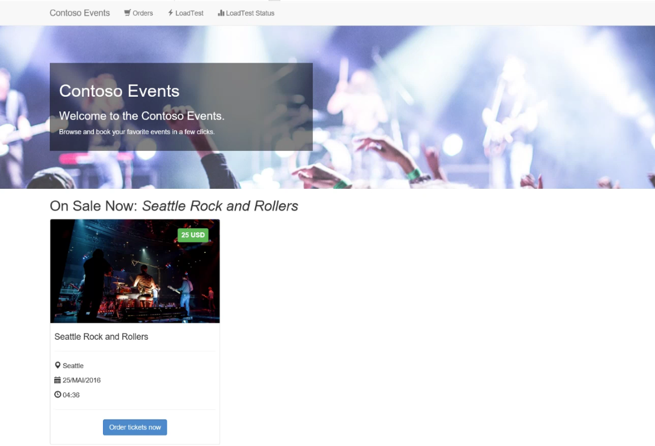

#### Tasks to complete

* From Visual Studio, run the ContosoEvents.Web application.
* Place an order from the web site, filling in the missing billing fields.

#### Exit criteria

* Once the order is queued for processing, you will be redirected to a results page indicating Success and showing you your order id that was queued as confirmation.

### Task 3: Publish the web app

In this task, you will publish the Web application to Azure.

#### Tasks to complete

* Publish the application to your Azure Web App you created previously named something like ‘contosoeventsweb-SUFFIX’.

#### Exit criteria

* When publishing is complete, your browser will launch and navigate to the deployed Web app home page. You can optionally submit another order to validate functionality works as in Task 2.

## Exercise 6: Upgrading

Duration: 30 minutes

In this task, you will make changes to the code and deploy an update to the application to enhance functionality. Specifically, the update addresses the area of concern related to changes in the ticket order model and the impact on the system as a whole.

This task will illustrate the mechanism that Service Fabric provides for upgrading an application in production.

### Task 0: How upgrade works

In Service Fabric, deployments can be either regular or upgrade. A regular deployment erases any previous deployment data while the upgrade deployment preserves it. There are advantages to upgrades:

* Stateful service data will not be lost during upgrade
* Availability remains during the upgrade

The following figure illustrates the deployment hierarchy:

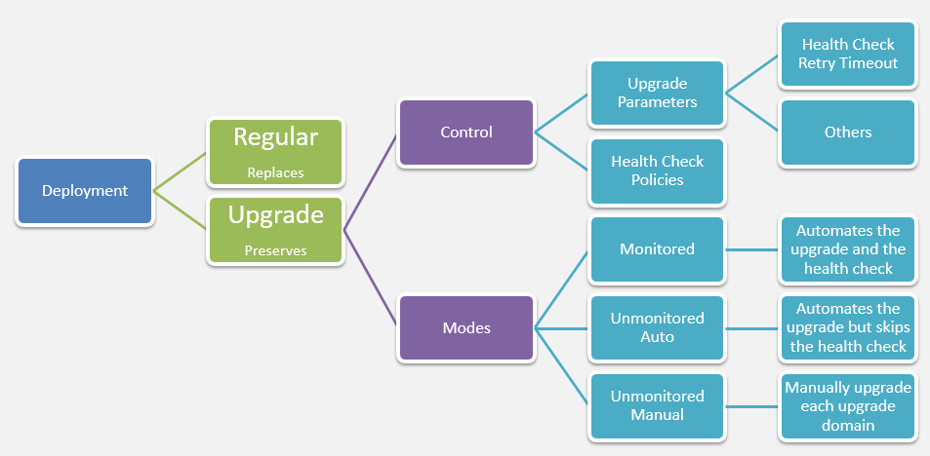

If you set the upgrade mode to Monitored, Service Fabric will be in full control of the upgrade process. There is a configurable time to wait after the upgrade has finished before Service Fabric evaluates the health of the application. This value defaults to 600 seconds.

### Task 1: Update an actor state

Currently, the TicketOrderActor does not have a status property to make it easier to check on the actor order status quickly. In this task, you will modify the Ticket Order State model to add a new status property.

#### Tasks to complete

* Add a state field to the TicketOrderActor by uncommenting the TODO: Exercise 6 – Task 1 sections in the solution.

#### Exit criteria

* After making this change, compile the solution and verify that there are no errors.

### Task 2: Perform a smooth upgrade

In this task, you will configure settings for the Service Fabric application to perform an upgrade.

#### Tasks to complete

* Publish the ContosoEventsApp using the Cloud.xml configuration, selecting the Upgrade option.
* Use ‘Monitored’ for the upgrade settings.
* Update the TicketOrderActor version to 1.1.0.
* View the upgrade status from the Visual Studio output window.
* Navigate to Service Fabric Explorer for the hosted cluster and watch the upgrade in progress.

#### Exit criteria

* When the upgrade is complete, from Service Fabric Explorer observe the new application version number.

### Task 3: Submit a new order

Now that the upgrade is completed successfully, you will submit a new order and make sure that the newly submitted order has the extended state.

#### Tasks to complete

1. From the Swagger endpoint of the API Management instance, submit a new order such as this:

{

"userName": "testupgrade",

"email": "test.upgrade@gmail.com",

"eventId": "EVENT1-ID-00001",

"paymentProcessorTokenId": "ggashwh565-uiewuu87-ujdsk",

"tickets": 3

}

#### Exit criteria

* Navigate to the DocumentDB query explorer and create a query using this order id to see the new extended state actually persisted to the database.

## Exercise 7: Rollback

Duration: 30 minutes

In this task, you will deploy an update that causes issues with the application, and will trigger an automatic rollback of the deployment. This exercise will illustrate the mechanism Service Fabric provides for preserving application health and availability in production.

### Task 1: Add health checks

In this task, you will add code to produce health checks that force the monitored upgrade to roll back to the original version of the service.

#### Tasks to complete

* Locate all TODO: Exercise 7 – Task 1 in the solution and uncomment the code as indicated.

#### Exit criteria

* Compile the code to ensure there are no issues with the changes.

### Task 2: Perform a troubled upgrade

In this task, you will perform an upgrade and watch a rollback of the upgrade.

#### Tasks to complete

* Publish the application to the cluster again. During the process, set the TicketOrderService new version to 1.1.0.
* From Service Fabric Explorer note the errors that appear.
* Try posting to the service and note that the application is still responsive.
* So that you do not forget, return to the code and re-comment the failure report so that you can do future exercise without rollback!

#### Exit criteria

* Look at the Visual Studio output window and note the rollback takes place after some seconds.
* Note that Service Fabric Explorer shows the rollback as well with the current deployment now set to the previous version.
* Also, note that the error remains until it is time to live expires or it is replaced by another health state. Until then, the unhealthy state will remain in the cluster but the cluster will be running normally. You can proceed without clearing this for now.
* The subsequent exercises (i.e. 8 and beyond) will be executed using version 1.1.0 and while the cluster shows unhealthy state. You can ignore this for now.
* Optionally, from the Swagger endpoint for the deployed application, you can request health statistics at the following relative URL: /api/admin/applicationhealth.

## Exercise 8: Load testing

Duration: 15 minutes

In this task, you will perform a load tests against the Service Fabric cluster and observe how messages are distributed across partitions.

### Task 1: Simulate a 50 order request

In this task, you will simulate a load test of 50 orders against the cluster using the Web application to submit the load test and monitor partitions.

#### Tasks to complete

1. Navigate to the published Web application at a URL like <https://contosoeventsweb-SUFFIX.azurewebsites.net>.
2. From the Load Test page, issue a load test for 50 iterations.
3. From the Load Test Status page, refresh and view the distribution of messages across the partitions where they are queued.

#### Exit criteria

* After a few minutes you will see that the queues are drained and the orders were processed.

**Note**: If you still have more time, run this again with additional iterations progressively such as 100, 150, 200, 250. Or, take a look at Exercise 9 in the answers area which takes you through a much more comprehensive load test and partition analysis process using the API endpoint.

## BONUS Exercise 9: Load testing w/Partitions

**If you completed the other work in good time and still have another 50 minutes free, have some load testing and partitioning fun! Otherwise, skip to cleanup.**

Follow the steps in the answers area for Exercise 9 and learn how to produce a partitioning metrics report.

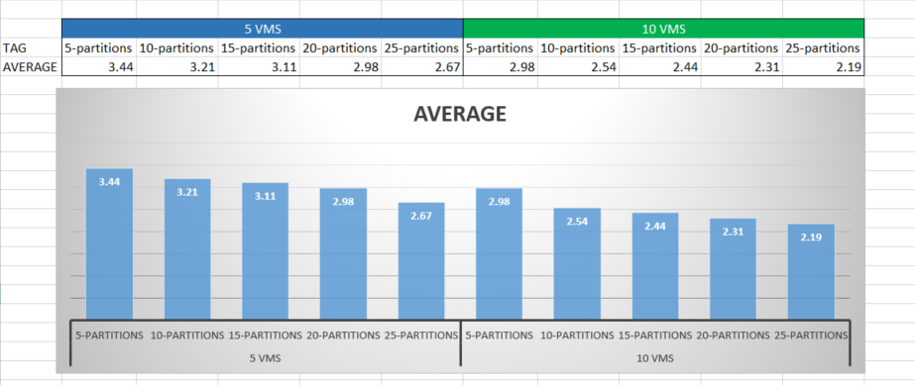

## BONUS Exercise 10: Secure the web application

**If you completed the other work in good time and still have another 30 minutes do this exercise and integrate Azure Active Directory B2C with the application. Otherwise, skip to cleanup.**

**For a challenge, follow these steps here, or go to the answers area for explicit steps and save some time researching.**

In this exercise, you will configure the Azure Active Directory B2C tenant and configure the Web front end to integrate with it for use login. Once all the settings are in place, you will be able to run the web site, register as a user, and login.

### Task 1: Configure the Azure Active Directory B2C

In this task, you will set up the Azure Active Directory B2C directory for your application to integrate with it.

#### Tasks to complete

* Register a new application in the Azure Active Directory B2C tenant you created previously.
* Add a reply URL for local testing:

<https://localhost:44327/>

* Add a reply URL for the hosted Web App as you named it, for example:

https://contosoeventsweb-SUFFIX.azurewebsites.net/

* Set local accounts to Username.
* Define policies for sign up, sign in and profile editing.
* For all policies, set Application Claims select Email Addresses, Given Name, Surname, and User’s Object ID.
* For profile attributes, choose Given Name and Surname.
* When done take note of the Application ID for later. Also, take note of the policy names.

#### Exit criteria

* Your B2C directory is ready for use and after Task 2 is complete, you will be able to exercise it.

### Task 2: Configure the Web App Settings

You will be guided through the instructions to find the information necessary to populate the configuration settings.

#### Tasks to complete

1. For the ida:Tenant enter the domain of the Azure Active Directory B2C you created such as ‘contosoeventsb2cSUFFIX.onmicrosoft.com’.
2. For the ida:ClientId enter the Application ID generated for your B2C application created in the previous task.
3. For the ida:SignUpPolicyId enter the name of the sign-up policy you created in the tenant (e.g., B2C_1_signup).
4. For the ida:SignInPolicyId enter the name of the sign in policy you created in the tenant (e.g., B2C_1_signin).
5. For the ida:UserProfilePolicyId enter the name of the profile editing policy you created in the tenant (e.g., B2C_1_profileedit).

#### Exit criteria

* You will have set all the required settings.

### Task 3: Add security features to the Web application

In this task, you will enable security features that will leverage the configuration you just applied.

#### Tasks to complete

* In the solution, look for all TODO Exercise 10 – Task 3 instructions and follow the steps.
* Compile the solution to ensure no issues.

#### Exit criteria

* Compile the application and ensure no errors before the next step.

### Task 4: Running the Web App and signing in

In this task, you will test the web application and register yourself as a user to log in to the Azure AD B2C tenant.

#### Tasks to complete

* Run the Web App.
* Register a new user and authenticate.
* Sign out and sign in again.

#### Exit criteria

* Note your email is shown in the application header after you sign in.

**Note**: You can optionally publish this application to Azure and test sign in, sign out continues to work from the deployed URL.

## Exercise 11: Cleanup

Duration: 10 minutes

In this exercise, attendees will de-provision any Azure resources that were created in support of the lab.

#### Tasks to complete

* Delete the Resource Group you created during this hackathon.
* Delete the Azure Active Directory B2C tenant.

#### Exit criteria

* After all of the deletion tasks are complete, the resources will no longer be listed in the Azure Portal or the Management Portal. This may take about 10 minutes. You can optionally wait to see a confirmation. Otherwise, you are done!

# Microservices and Serverless Architecture Hackathon answers

## Overview

Contoso Events is an online service for concerts, sporting and other event ticket sales. They are redesigning their solution for scale with a microservices strategy and want to implement a POC for the path that receives the most traffic: ticket ordering.

In this Hackathon, you will construct and load test an end-to-end POC for ticket ordering. You will leverage Service Fabric, API Management, Function Apps, Web Apps, Document DB, and Azure Active Directory B2C. You can do a few BONUS exercises if you still have time after running through the primary exercises.



**IMPORTANT: Most Azure resources require unique names. Throughout these steps, you will see the word “SUFFIX” as part of resource names. You should replace this with your Microsoft alias or other username to ensure the resource is uniquely named.**

## Requirements

* Microsoft Azure subscription must be pay-as-you-go or MSDN.
  + Trial subscriptions will *not* work.
* Local machine or a virtual machine configured with:
  + Visual Studio 2015 with Update 3 or later
  + [Azure SDK 2.9.1 or later for Visual Studio 2015](https://azure.microsoft.com/en-us/downloads/)
  + [Service Fabric SDK 2.4.145 (with Runtime 5.4.145)](https://docs.microsoft.com/en-us/azure/service-fabric/service-fabric-get-started) for use with Visual Studio 2015
  + Azure PowerShell 1.0.0 or later
  + A browser such as Edge, Chrome, or Firefox (IE does not work with Swagger commands)

## Exercise 0: Before the Hackathon

Duration: 15 minutes (plus 30 minutes or more provisioning time)

You should follow all of the steps provided in Exercise 0 *before* attending the hackathon.

**If you forget to do this before the hackathon, you should proceed to Exercise 1 before the service fabric cluster completes in Task 2 of this section, so that you do not lose time.**

### Task 1: Resource Group

You will create an Azure Resource Group to hold all items that you create in this Exercise. This approach will make it easier to clean up later. Because you will want to include the Service Fabric Cluster that you create in the same Resource Group as other resources you create during the remaining exercises, you will create the Resource Group now.

**Note**: This Resource Group will be used for all resources you create with one exception, for the Function App. This document will refer to this Resource Group as the “resource group you created previously” since this is the primary Resource Group.

1. In your browser, navigate to the **Azure Portal** (<https://portal.azure.com>).
2. Click +New in the navigation bar at the left.



1. In the search field, type Resource Group and press enter.
2. From the list, select Resource Group.
3. Create a new Resource Group. Name it something like “contosoevents-SUFFIX” as shown in the following screen shot.
4. Select the subscription you will use for all the steps during the hackathon.
5. Choose a region and remember this for future steps so that the resources you create in Azure are all kept within the same region.

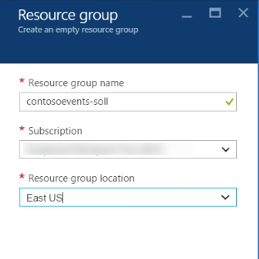

1. From the left hand menu, select Resource groups.
2. Your Resource Group should be listed in the Azure Portal.

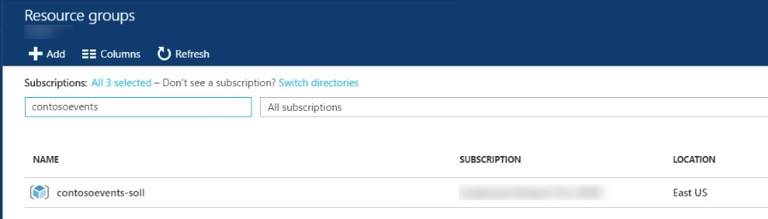

### Task 2: Service Fabric

In this section, you will provision the Service Fabric Cluster.

1. From the Azure Portal, select New -> Compute -> Service Fabric Cluster



1. From the Basics blade of the Create Service Fabric Cluster setup, provide a unique cluster name such as “contosoeventssf-SUFFIX” as shown in the following screen shot.
2. Leave the Operating system set to Windows.
3. Provide a username and password for the VM.
4. Select the subscription.
5. Select ‘Use existing’ resource group and choose the Resource Group you previously created.
6. Choose the same region that you did before.
7. Click OK to complete the Basics blade.

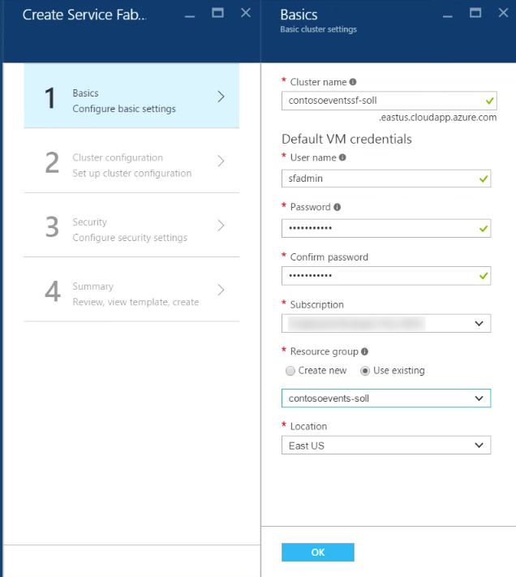

1. From the Cluster Configuration blade, leave the default Node type count as shown in the following screen shot.
2. Click Node type 1 to configure required settings and provide a Node type name of Web.
3. Leave the default value for Durability tier, Reliability tier, and leave Initial VM scale set capacity at 5 nodes.
4. For Custom endpoints, enter 8082. This will allow the Web API to be accessible through the cluster.

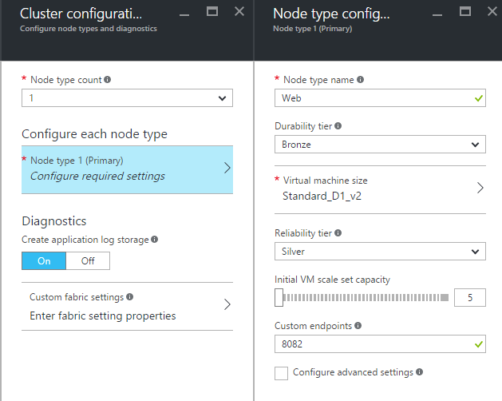

1. Select VM size D1_V2 standard as shown in the following screen shot before clicking OK on the Node type configuration blade.

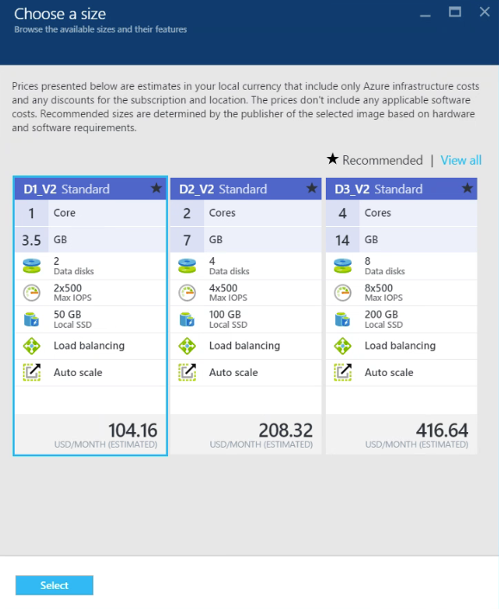

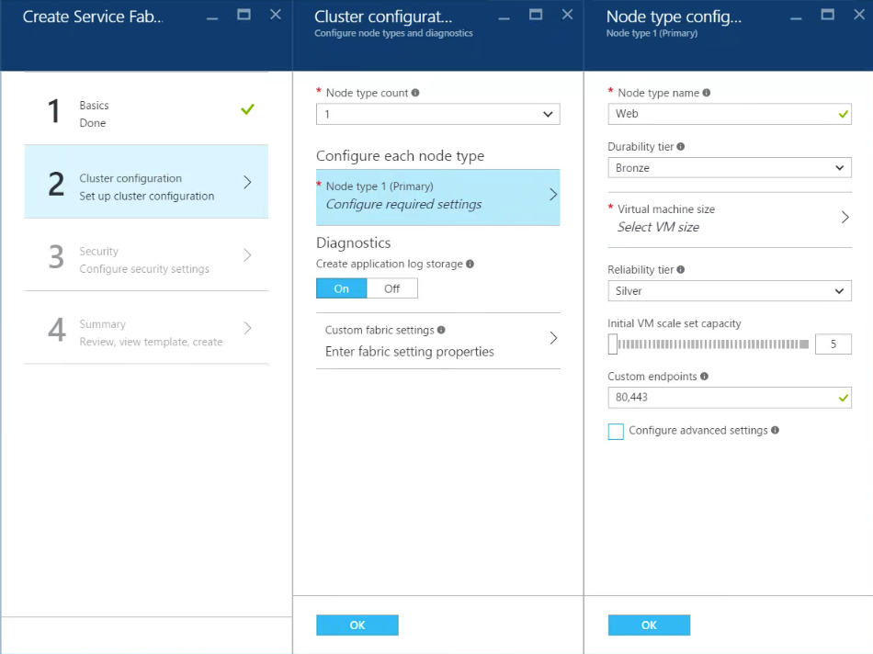

1. Leave the Diagnostics on and click OK to complete Cluster configuration.
2. From the Security blade, you have an opportunity to provide security settings for the cluster. This is a configuration made up front that cannot be changed later. Without this setting in place, anyone can reach the cluster. That said, in the interest of time during this hackathon only you will set the cluster security mode to Unsecure as shown in the following screen shot.

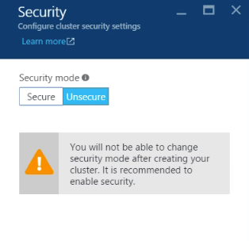

1. Click OK to review a summary of this configuration.
2. Review the summary and click Create to begin creating the new cluster.

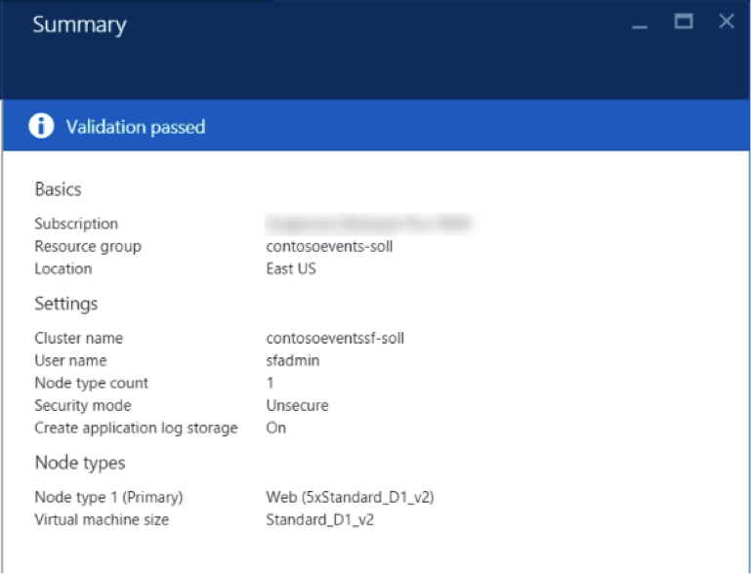

1. It can take up to 30 minutes or more before your Service Fabric Cluster is listed in the Azure Portal in the Resource Group that you created earlier.

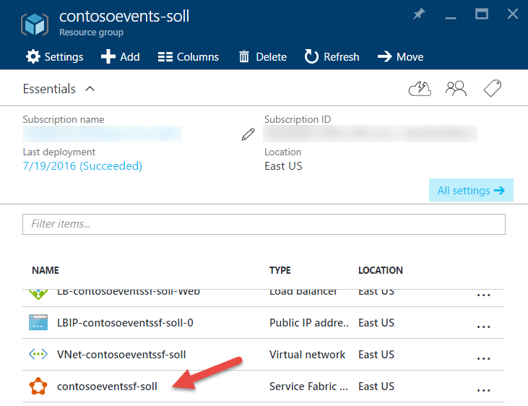

**Note**: If you experience errors related to lack of available cores, you may have to delete some other compute resources or request additional cores be added to your subscription and then try this again.

### Task 3: Validate Service Fabric ports

Occasionally, when you create a new Service Fabric Cluster using the portal, the ports that you requested are not created. This will become evident when you try to deploy and run the Web App, because the required ports will not be accessible through the cluster.

In this task, you will validate that the ports are open and if not, fix the issue.

1. Navigate to the Resource Group you created previously, and where you created the cluster. If it is still deploying, do not proceed to the next step until deploying is completed.

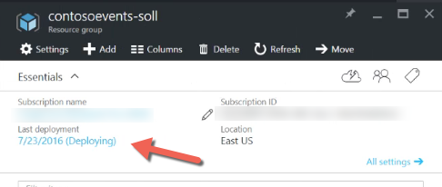

1. Select the load balancer.



1. From the Settings blade, select Health Probes.
2. Verify if a probe exists for port 8082:

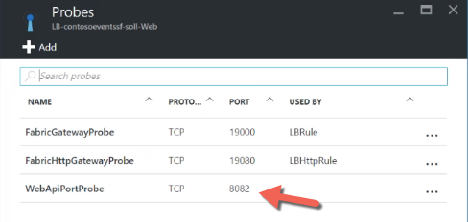

1. If there is, select it and verify that it is “used by” a load balancing rule. This should be indicated at the bottom of the probe blade. If it is, you can skip this step – the probe and load-balancing rule requested in the template will have been correctly created. Otherwise, proceed to the next step to create the probe and the load-balancing rule.
2. Click Add from the Probes blade.
3. Supply the name ‘WebApiPortProbe’ and select TCP protocol.
4. Enter 8082 for the port.

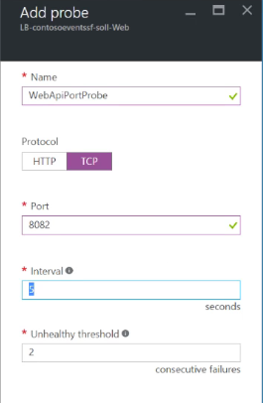

1. Click OK to create the probe.

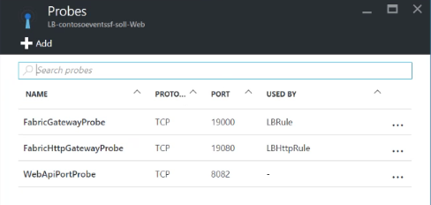

1. Create a rule associated with this probe. From the Settings blade, select Load balancing rules.



1. Click Add.
2. Set the name to ‘LBWebApiPortRule’.
3. Leave protocol as TCP.
4. Set the Port and Backend port to 8082.
5. From the Health Probe list, select your previously created WebApiPortProbe.
6. Click OK.
7. If you get an error notification such as “Failure to create probe”, ignore this but just go check that the probe indeed exists. It should.

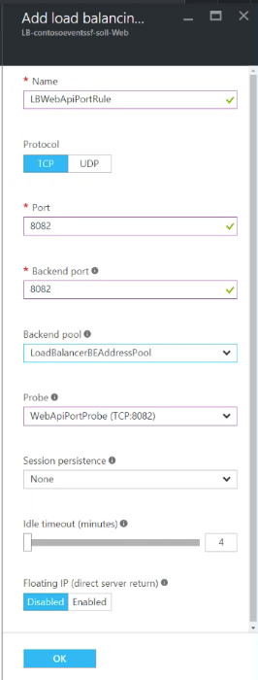

1. You will now have a cluster ready to deploy to and expose 8082 as the Web API endpoint / port.

## Exercise 1: Environment setup

Duration: 30 minutes

Contoso Events has provided a starter solution for you. They have asked you to use this as the starting point for creating the Ticket Order POC solution with Service Fabric.

Because this is a “born in Azure” solution, it depends on many Azure resources. You will be guided through creating those resources before you work with the solution in earnest. The following figure illustrates the resource groups and resources you will create in this exercise.



### Task 1: Download and open the ContosoEventsPoc Starter

1. Download the starter project from the following URL: <http://bit.ly/2jyZqbd>
2. Unzip the contents.
3. Open ContosoEventsPoc.sln with Visual Studio.
4. Before you compile the solution set the configuration to x64.



**Note**: If you have the prerequisites on your VM, this solution should open without requesting additional software to be installed. You will also be able to compile without error, but the solution is not yet ready to run.

1. Make sure you can compile.

### Task 2: API Management

In this section, you will provision an API Management Service.

1. Login to the Azure Portal.
2. Click +NEW  
   
3. Select API Management from the Web + Mobile group.  
   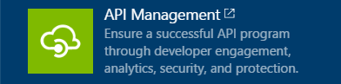
4. In the API Management Service blade, provide:
   1. A unique URL for the API Management service as shown in the following screen shot.
   2. Choose the subscription.
   3. Choose the same region and Resource group that you specified previously.
   4. Enter the Organization Name ‘Contoso Events’.
   5. Provide an Administrator Email, such as your email address.
   6. Select the Developer Pricing tier.  
      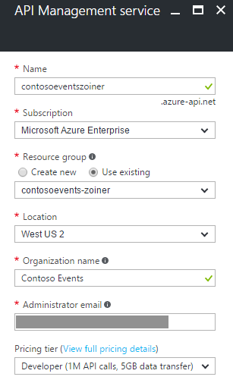
5. Click Create to provision the API Management service.
6. After it is provisioned, the service will be listed in the Resource Group. This may take up to 10-15 minutes, so move to Task 3 and return later to verify.

### Task 3: Azure Active Directory B2C

In this section, you will provision an Azure Active Directory B2C tenant. You will use this if you do BONUS Exercise 10 so it is best to set it up in advance to avoid having to wait for provisioning.

1. Navigate to the Azure classic portal at <http://manage.windowsazure.com/>
2. Select + New, App Services, Active Directory, Directory, Custom Create.
3. In the Add Directory dialog, provide a name for the tenant such as ‘contosoeventsb2cSUFFIX’ as shown in the following screen shot.
4. Provide a unique domain name for the tenant such as ‘contosoeventsb2cSUFFIX’.
5. Choose United States for the region and select the This is a B2C directory check box.

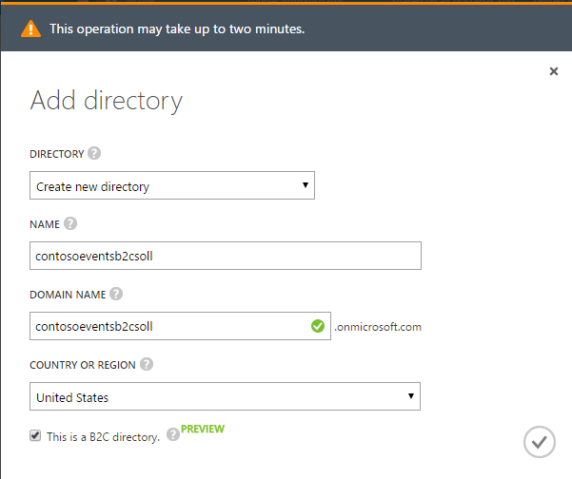

1. Click the checkmark to create the Azure Active Directory B2C tenant.
2. After the tenant it is provisioned, it will be displayed in the Active Directory list in the Management Portal. This may take up to 5 minutes, so move to Task 4 and return later to verify.

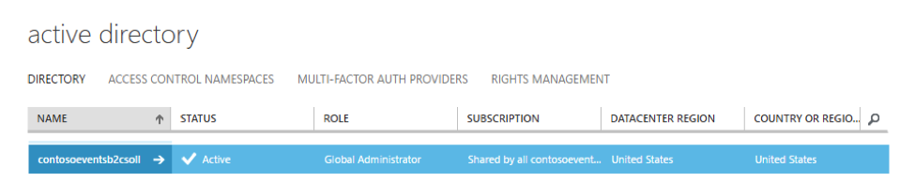

### Task 4: Web App

In these steps, you will provision a Web App in a new App Service Plan.

1. Click + New in the Azure Portal.



1. Select Web App from the Web + Mobile group.

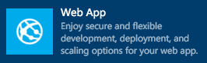

1. On the Web App blade, provide an App name such as ‘contosoeventsweb-SUFFIX’.

**Note**: This will form the URL you will use to access the web site once it is deployed. For example: <https://contosoeventsweb-SUFFIX.azurewebsites.net>.

1. Choose your Subscription and select Use existing Resource Group, selecting the same one you are using for other resources as shown in the following screen shot.

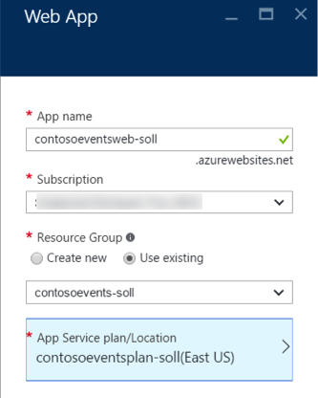

1. Create a new App Service plan. Provide a name such as ‘contosoeventsplan-SUFFIX’ as shown in the following screen shot.
2. Select the same region you have used previously.
3. Select the Pricing tier of S1 Standard.
4. Click OK in the new App Service Plan blade and then click Create in the new Web App blade. This will provision both the App Service Plan and the Web App.

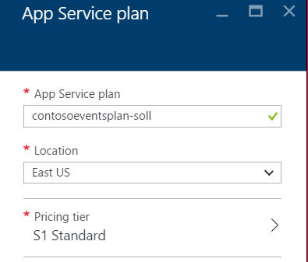

1. You can navigate to your new Web App at the URL you noted earlier based on your Web App name such as <https://contosoeventsweb-SUFFIX.azurewebsites.net>. You should see an empty website.

### Task 5: Function App

In these steps, you will provision a Function App using a Consumption Plan.

**Note**: Functions are able to dynamically scale if you use a Consumption Plan. At this time, you cannot select a pre-existing Resource Group and select this type of plan – so in this section you will create a second Resource Group intentionally, as a workaround.

1. Click + New in the Azure Portal.



1. Select Function App from the Compute group.

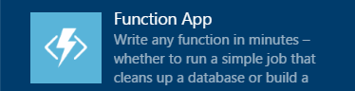

1. Provide a name such as ‘contosoeventsfn-SUFFIX’ as shown in the following screen shot.
2. Choose the same Subscription as used previously.
3. Create a new Resource Group called ‘contosoeventsfn-SUFFIX’.

**Note**: As mentioned, at this time the Dynamic App Service Plan option is not available when you select an existing Resource Group.

1. Select the Consumption Plan option for the Hosting Plan.
2. Select the same region you have used previously.
3. Click Create.

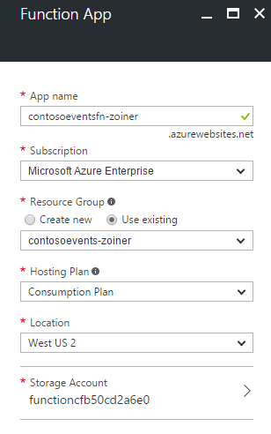

1. When the provisioning completes, your Web App and Function App are listed in the Azure Portal.

### Task 6: Storage account

In this section, you will create a Storage account for the application to create and use queues required by the solution.

#### Tasks to complete

1. Click + New in the Azure Portal.



1. Select Storage Account from the Storage group.



1. In the Create Storage account blade, provide a name such as ‘contosoeventsSUFFIX’ for the account as shown in the following screen shot.
2. Leave the Deployment model as Resource Manager, and Account kind as General Purpose.
3. Set Performance to Standard.
4. Set Replication to ‘Locally-redundant storage (LRS)’.
5. Choose your Resource Group and Location to be consistent with previous selections.

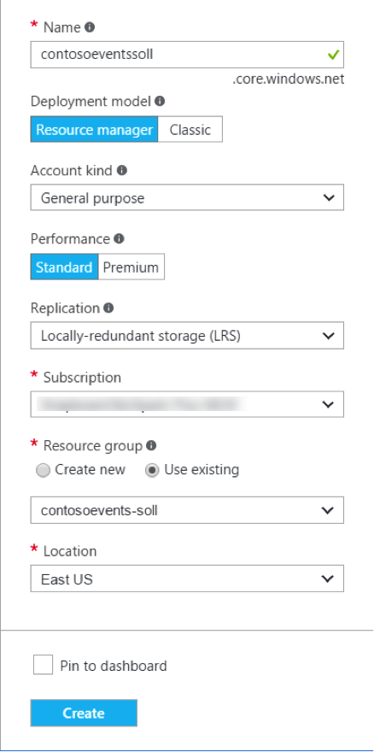

1. Click Create.
2. After provisioning is complete, the Storage account will be listed in the Azure Portal.

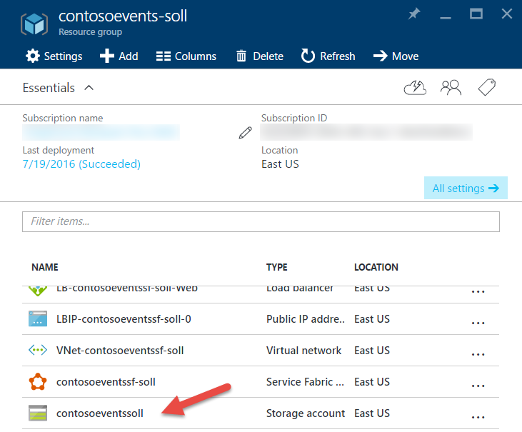

### Task 7: DocumentDB

In this section, you will provision a DocumentDB account, a DocumentDB Database and a DocumentDB collection that will be used to collect ticket orders.

1. Click + New in the Azure Portal.  
   
2. Select NoSQL(DocumentDB) from the Databases group.
3. Provide an ID for the DocumentDB account such as ‘contosoeventsdocdb-SUFFIX’.
4. Leave the NoSQL API set to DocumentDB.
5. Choose the Subscription.
6. Choose the same Resource Group and Location that you have used previously.

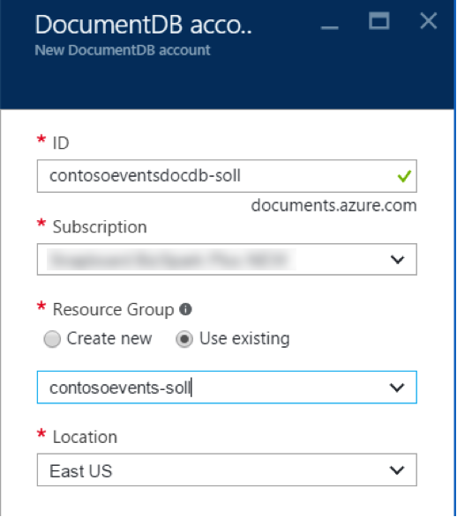

1. Click Create.
2. When the DocumentDB account is ready, go to the Resource Group, and choose your DocumentDB account from the list.

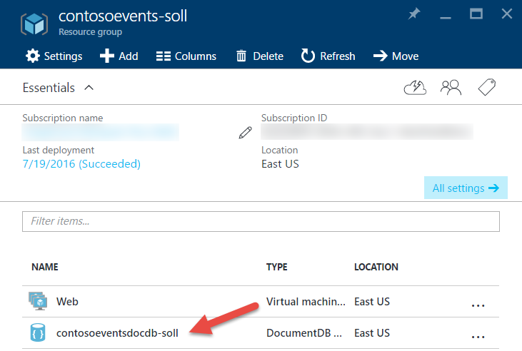

1. On the DocumentDB account blade, select Add Collection.



1. Set the collection ID to “Orders”.
2. Set the Storage Capacity to 10GB
3. Leave the Throughput Capacity at 1000.
4. Ensure Create new is selected for Database and provide the ID “TicketManager”.

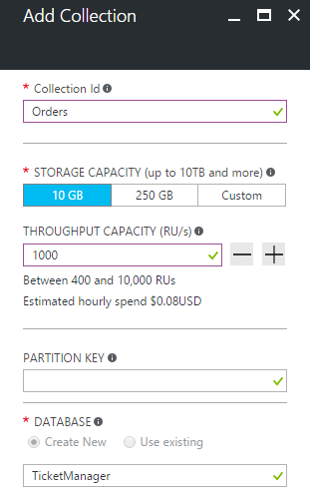

1. Click OK.
2. Click Add Collection again to add the Events collection.
3. Set the collection ID to “Events”.
4. Use the same settings as for Orders in the Add Collection blade.
5. Click OK.
6. You will be able to see that the two collections exist in the new database.

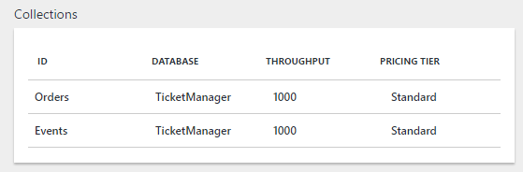

## Exercise 2: Placing ticket orders

Duration: 30 minutes

The agreed upon design with Contoso Events involves queuing ticket orders and executing them asynchronously. A stateless Web API service receives the request and queues it to a stateful service. An actor processes the request and persists the order in its state.

The design also calls for saving the state of the ticket order to a DocumentDB collection for ad hoc queries. This exercise will guide you through adding configurations that will light up the actor code that externalizes its state to a storage queue. In addition, you will set up the Function App to read from the queue and persist the order to the Orders collection of the DocumentDB instance you created.

**Note**: The code to write to the storage queue is already in place within the actor, so setting up configuration keys is the only requirement to lighting up that feature.



### Task 1: Run the solution

The purpose of this task is to make sure that the source code compiles and that you are able to publish to a local cluster. To make sure that the app is running flawlessly, you will run some API tests and access the Service Fabric explorer.

**Note**: Not all features are in place but you will be able to see that the application can run.

1. Make sure the local Service Fabric environment is running. From the task bar select the arrow and see if Service Fabric icon appears.

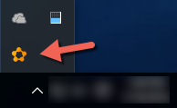

1. If not, start service fabric on the machine. Click the Start menu and type Service Fabric. Select Service Fabric Local Cluster Manager.

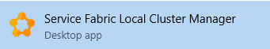

1. The Service Fabric icon mentioned previously should appear. You can right-click this and select Setup Local Cluster, 1 Node.

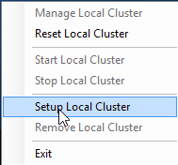

**Note**: Sometimes you will see an error message appear indicating the cluster setup is retrying.

1. In Visual Studio 2015 open the solution ContosoEventsPoc.sln
2. Rebuild the solution to resolve all NuGet packages and to make sure there are no compilation errors.
3. Publish the Service Fabric app to the local cluster. From Solution Explorer, right-click the Service Fabric Application, ContosoEventsApp. Select Publish.

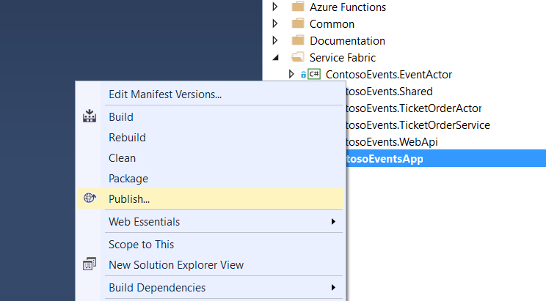

1. In the Public Service Fabric Application dialog, select Local.1Node.xml for the target profile as shown in the following screen shot.
2. Click Publish.

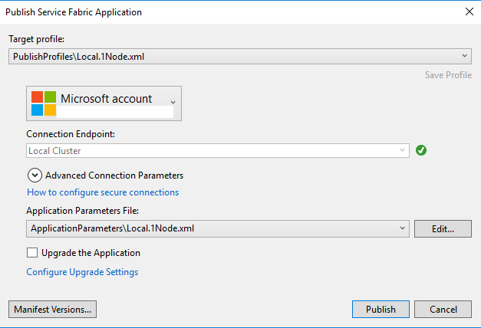

**Note**: If you have an error such as: “The project does not have a package action set.” you can restart Visual Studio, re-open the solution, and this will resolve the problem.

1. In Visual Studio view the publish status. After it shows that it succeeded, the application is ready to be used.

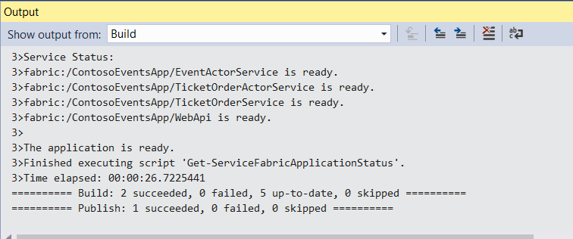

### Task 2: Test the application

The Service Fabric Application includes a front-end Web API as the public-facing window to internal stateful services. In this task, you will check that you can call the Web API now that you have the application published to the local cluster. Because the app is not yet fully configured, not all Web API methods will be fully functional.

1. From the browser, navigate to the Swagger endpoint for the Web API at:

<http://localhost:8082/swagger/ui/index>

1. Note the three API endpoints: Admin, Events, and Orders:

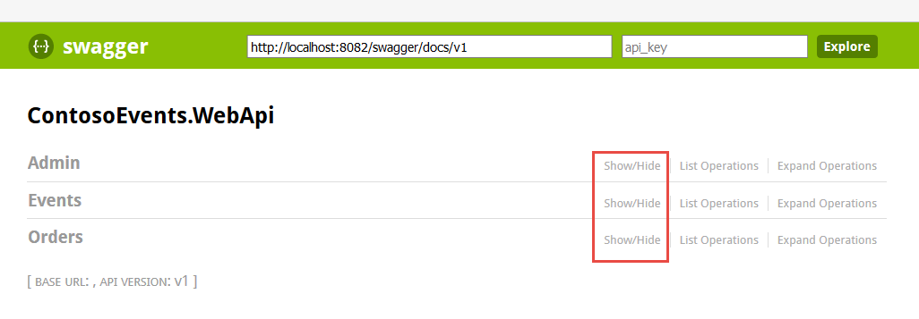

1. Select the Admin API and note the following list of methods are available:

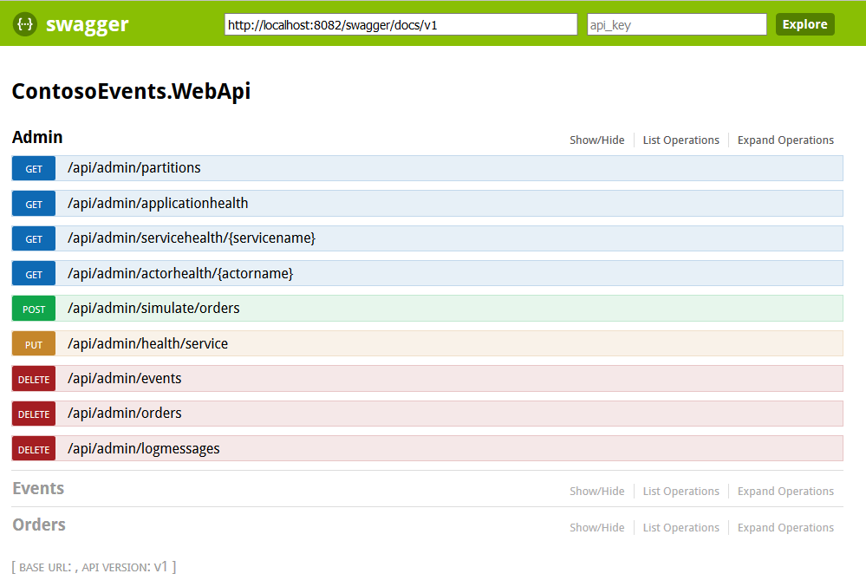

1. Select /api/admin/partitions, click ‘Try it out’, and make sure it returns a response of 200 as shown in the following screen shot. This returns the number of tickets queued across all partitions.

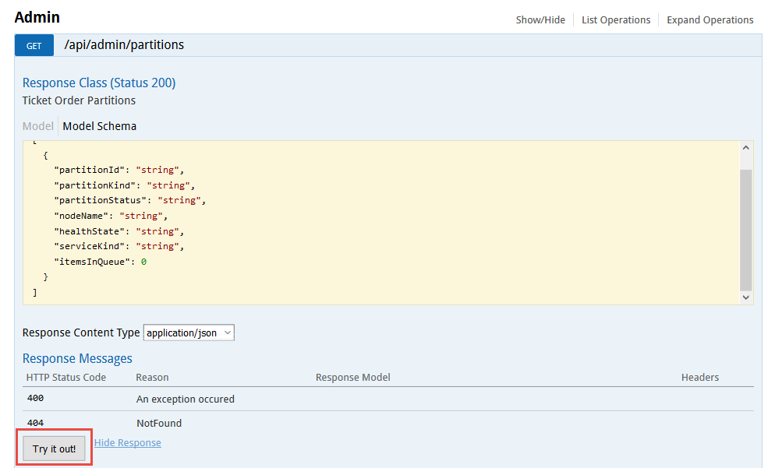

1. If you were able to view the Swagger definition and select the partitions method with a successful response, your environment is in a good state to continue.

### Task 3: Service Fabric Explorer

In this task, you will browse to the Service Fabric Explorer and view the local cluster.

#### Tasks to complete

1. In a new browser tab, navigate to the Service Fabric Explorer for the local cluster at:

<http://localhost:19080/Explorer/index.html>.

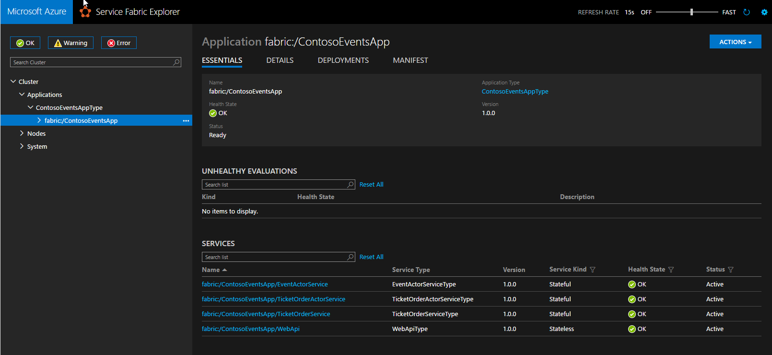

1. Observe that the ContosoEventsApp is deployed with the following services:
   1. fabric:/ContosoEventsApp/EventActorService
   2. fabric:/ContosoEventsApp/TicketOrderActorService
   3. fabric:/ContosoEventsApp/TicketOrderService
   4. fabric:/ContosoEventsApp/WebApi
2. If you are able to access the Service Fabric Explorer your environment is in a good state to continue.

### Task 4: Set up the Ticket Order Sync queue

The purpose of this task is to complete features of the Contoso Events POC so that placing an order also syncs with the back end data store. You will also update the configuration settings to reference the Azure resources you previously created correctly.

#### Update configuration settings

1. From Solution Explorer, open Local.1Node.xml from the ContosoEventsApp project under the ApplicationParameters folder.
2. Following this section you will be shown where to get the values to update Local.1Node.xml in the ApplicationParameters folder with your own configuration parameters for the following items:

<Parameter Name="DataStorageEndpointUri" Value="" />

<Parameter Name="DataStoragePrimaryKey" Value="" />

<Parameter Name="DataStorageDatabaseName" Value="TicketManager" />

<Parameter Name="DataStorageEventsCollectionName" Value="Events" />

<Parameter Name="DataStorageOrdersCollectionName" Value="Orders" />

<Parameter Name="StorageConnectionString" Value="" />

<Parameter Name="ExternalizationQueueName" Value="ticketorders-externalization" />

<Parameter Name="SimulationQueueName" Value="ticketorders-simulation-requests" />

#### DocumentDB settings

1. From the Azure Portal, browse to the DocumentDB you created previously and select Keys.
2. Set DataStorageEndpointUri to the DocumentDB endpoint Uri.
3. Set DataStoragePrimaryKey to the DocumentDB Primary Key.
4. If you used a different database name, modify DataStorageDatabaseName to reflect the DocumentDB database name.

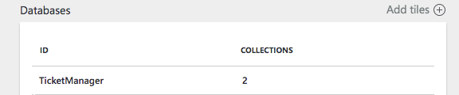

1. If you used a different collection name for Orders and Events collections, modify DataStorageEventsCollectionName and DataStorageOrdersCollectionName to match your choice.

#### Storage settings

1. From the Azure Portal, browse to the Storage account you created previously. Select Access Keys.
2. To the right of key1, click the ellipses (…) and select View Connection String.
3. Copy the value displayed in the dialog.
4. Paste the value in StorageConnectionString setting and save Local.1Node.xml.

#### Test configurations

1. Rebuild and publish the application to the local cluster using the steps you followed previously.
2. After the application is fully published, browse to the Swagger endpoint at <http://localhost:8082/swagger/ui/index>.
3. Show the Orders API methods and select the operation for POST /api/orders.

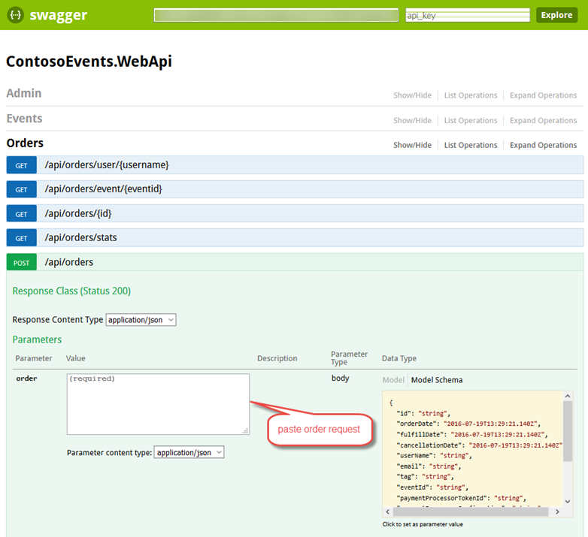

1. POST an order to the Contoso Events application. Copy this order request as shown into the api/orders content value and click Try it out.

{

"UserName": "johnsmith",

"Email": "john.smith@gmail.com",

"EventId": "EVENT1-ID-00001",

"PaymentProcessorTokenId": "YYYTT6565661652612516125",

"Tickets": 3

}

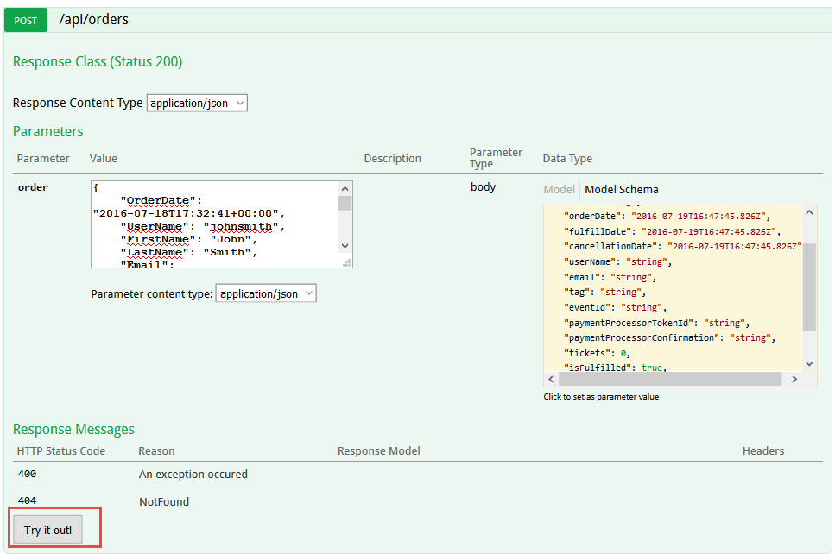

1. This should return successfully with HTTP 200. The response includes a unique order id that clients could use to track the order.

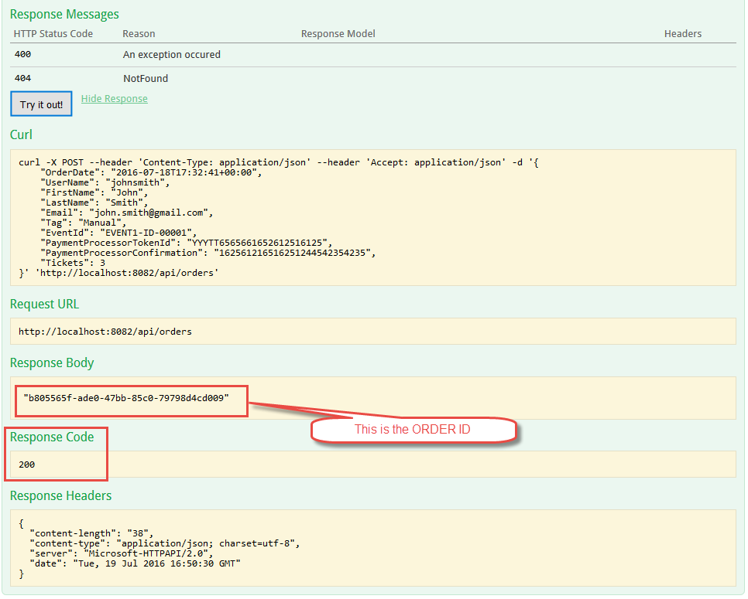

**Note**: This sends the order to the Web API, which in turn queues the order with the Ticket Order Processing queue. Ultimately, the Ticket Order Actor will pick up the message and process the order.

1. Now you should have an order in the Service Fabric App and it is being processed. In addition, the Ticket Order Actor should have sent the order to the externalization queue you set up in configuration earlier. The actor has pre-existing logic in place to write to this queue.
2. To verify that the order is in the queue. From the menu in Visual Studio, select View -> Cloud Explorer to open the Cloud Explorer pane.

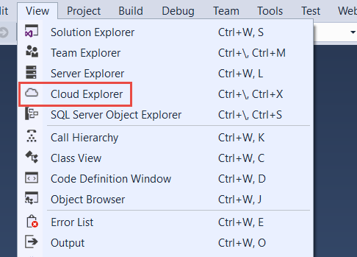

1. Find the Storage account you set up previously and expand it to list queues. You may need to re-enter your credentials to see the Storage accounts. If you do not see any queues to expand, login to your Microsoft Account.
2. Double-click on the externalization queue and you should see the message you just sent in the document window. Double-click on the message and you will see the contents of the message including the JSON representation of the order.

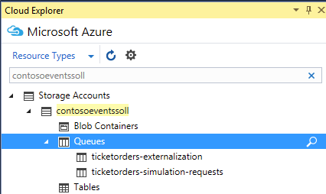

### Task 5: Set up the functions

The purpose of this task is to create a function that will be triggered by the externalization queue we created for the app. Each order that is deposited to the queue by the TicketOrderActor type will trigger the ProcessOrderExternalizations function. The function then persists the order to the Orders collection of the DocumentDB instance.

In this task, you will also create a second function that will be used to generate load against the system at runtime. Overall, the ContosoEvents app has the following queue and function architecture and this should help visualize how the queues and functions are related:



#### Tasks to complete

1. From the Azure Portal, access the Function App you created previously.
2. From the Function app blade, select New Function.

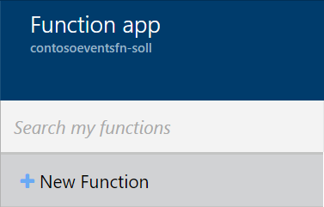

1. When you are prompted to choose a template, please select the QueueTrigger CSharp as shown in the following screen shot.

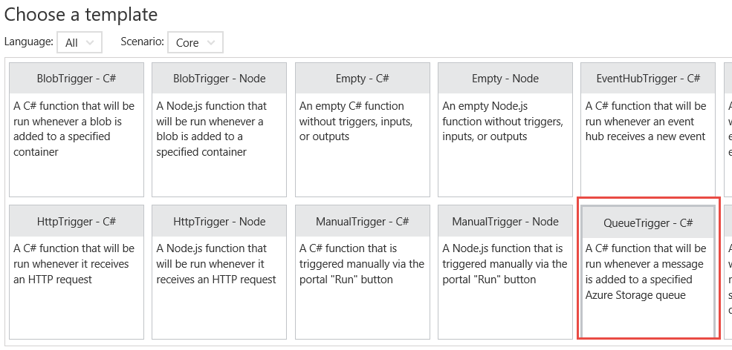

1. Provide the name ‘ProcessOrderExternalizations’.
2. Provide the externalization queue name, ‘contosoevents-externalization-requests’.
3. Under Storage account connection, click New.
4. Select the Storage account you created previously, where the queue will be located.
5. Click Create.
6. If the function is created properly you will see the ‘Develop’ tab of the function as shown in the following screen shot.

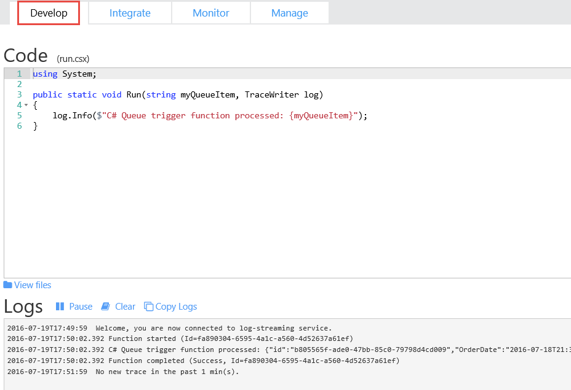

1. Click the ‘Integrate’ tab.
2. Make sure Azure Queue Storage is selected under Triggers.
3. Set the Message parameter name to ‘orderItem’.
4. Set the queue name to contosoevents-externalization-requests.
5. Select the Storage account connection to match the account name you created earlier.
6. Click Save (IMPORTANT or the message parameter name will not be saved!).
7. Click New Output

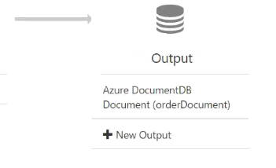

1. Click Azure DocumentDB Document and click Select.

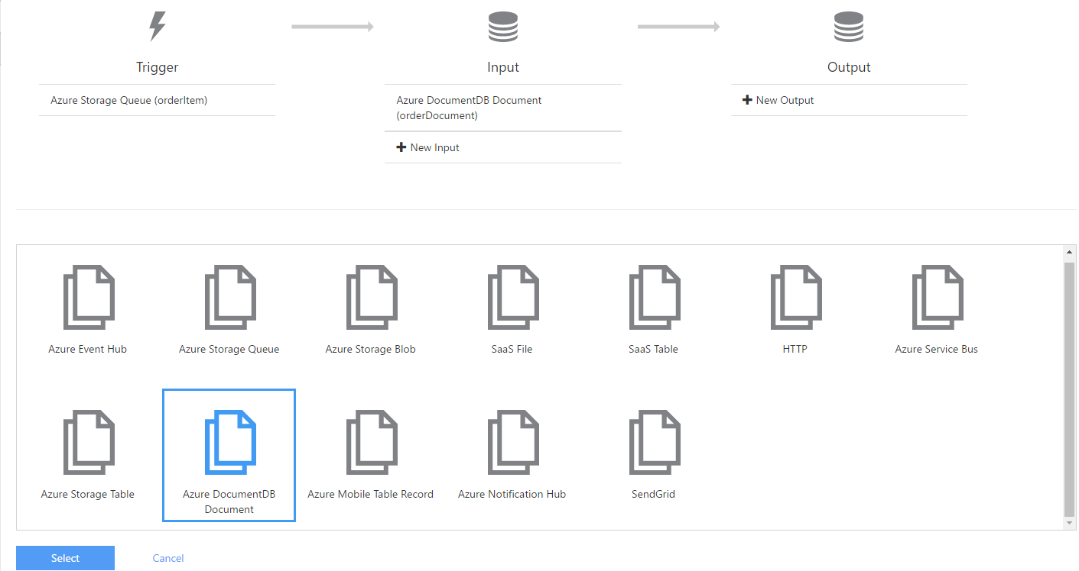

1. Now you will supply parameters for the DocumentDB output.
2. Enter the document parameter name ‘orderDocument’.
3. For Collection Name enter ‘Orders’.
4. For Database name, enter the database you created previously, ‘TicketManager’.
5. For Document DB account connection, select New and choose your DocumentDB Account.
6. Click Save.

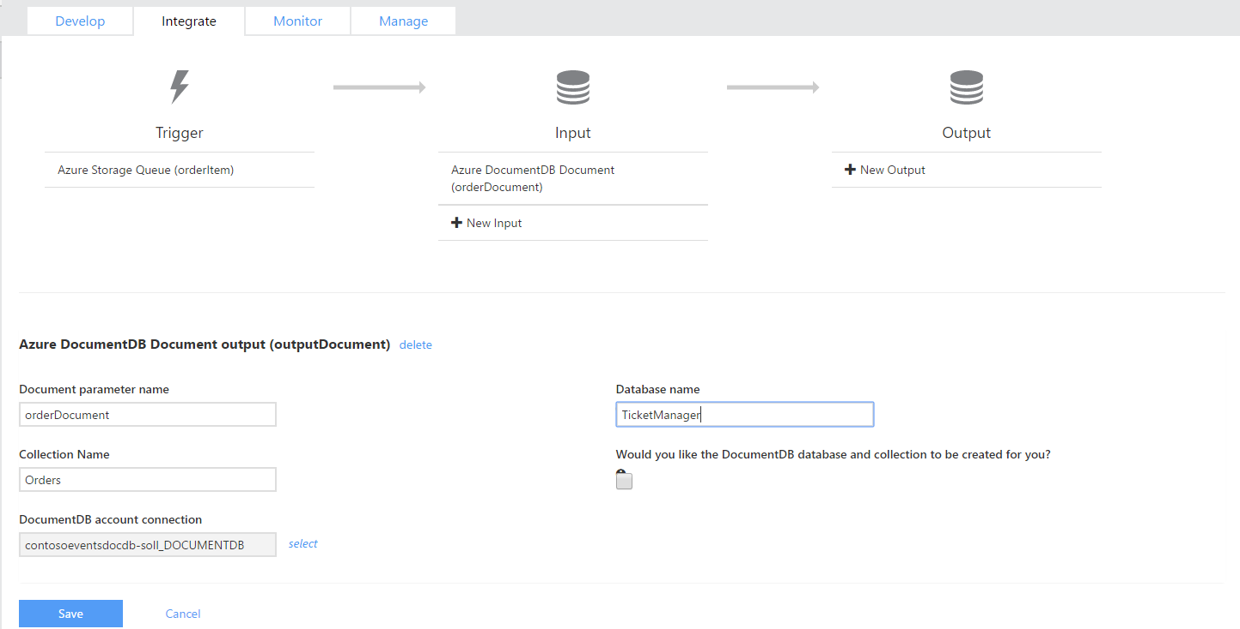

1. Select the Develop tab. You will go to the Visual Studio solution for the function code to place here.
2. From Visual Studio, go to Solution Explorer and locate ProcessTicketOrderExternalizationEvent.cs in the Azure Functions folder.
3. Copy and paste this code into the Code window.

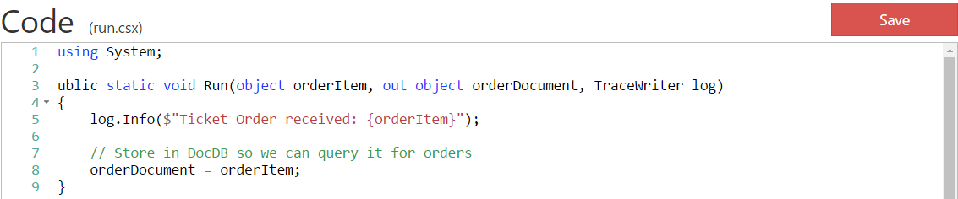

1. Click Save.
2. From the Logs section, note that the function compiled successfully.

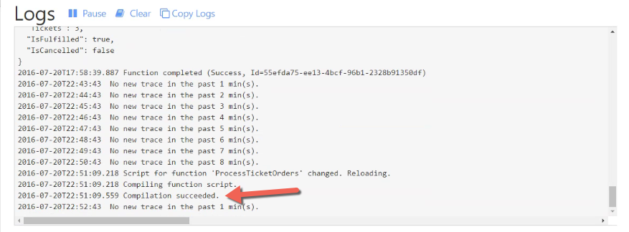

**Note**: Because the ProcessOrdersExternalization function is set up, you will be able to process another order and see that it is saved to the Orders collection of the DocumentDB.

1. Now you will create another function for the load simulation you will use later on in this hackathon. You will follow the same steps in this section with the following differences:
   1. Select + New Function.
   2. From the templates scenario list choose All.

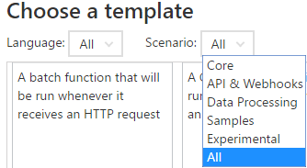

* 1. Select the template QueueTrigger – PowerShell (instead of C#)
  2. Set the function name to ‘ProcessSimulationRequests’.
  3. Set the queue name to ‘contosoevents-simulation-requests’.
  4. Set the Storage account connection to the Storage Account you have been using.
  5. Click Create
  6. Click on the Integrate tab.
  7. With the Azure Storage Queue input trigger selected, change the message parameter name to ‘simulationRequest’.
  8. In this case, there is no need to set up an output so you can skip this step.
  9. Click Save.
  10. Click on the Develop tab.
  11. From Visual Studio, in Solution Explorer, find the file ProcessTicketOrderSimulationRequest.PS1 in the Azure Functions folder. Copy the contents of this file into the code text area and click Save.
  12. The final setting to update is the API Management key. You will return to set this up when you set up the API Management service.
  13. If each function successfully compiled as you went through these steps, you are ready to proceed to the next exercise.

### Task 6: Test order data sync

In this task, you will test the ticket order processing back end to validate that orders are queued and processed by the TicketOrderProcessing function – ultimately saving the order to the Orders collection of the DocumentDB instance.

1. From the Azure Portal, navigate to the Function App.
2. Select the ProcessOrderExternalizations function and leave the Develop tab open with the Logs section visible.

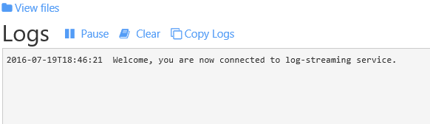

1. Repeat the necessary steps from Task 4 to submit an order.
2. As orders are processed, you will see activity in the function logs.

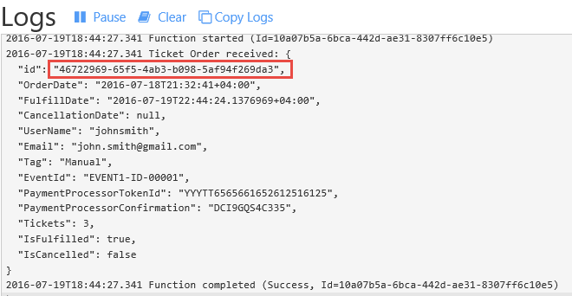

1. Note the order id of the function just processed. Use this information to verify the order is persisted to the Orders collection.
2. From the Azure Portal navigate to your DocumentDB account and from the items on the left, choose Query Explorer.
3. In DocumentDB query explorer, set the Collections option to Orders and run the following query using the order id noted in the logs:

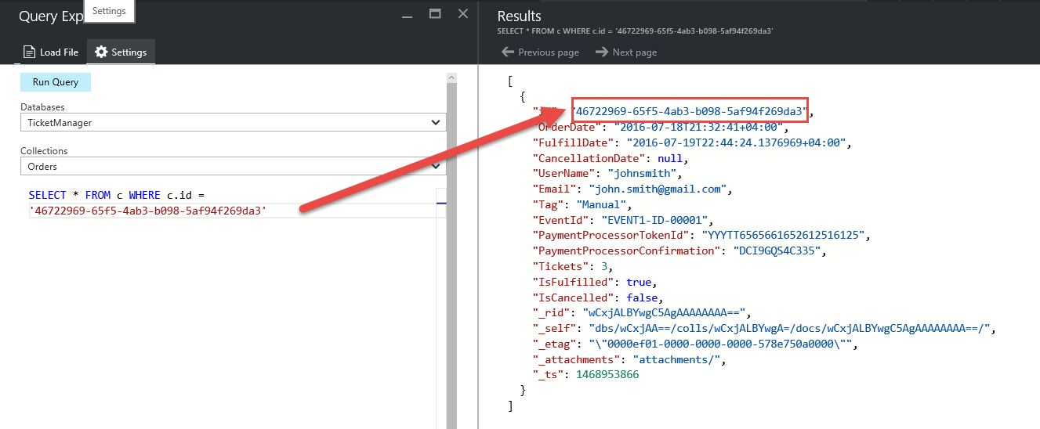

1. If the DocumentDB query returns the order id specified, the order has been fully processed through to the DocumentDB.

## Exercise 3: Publish the Service Fabric Application

Duration: 15 minutes

In this exercise, you will publish the Service Fabric Application to the Azure cluster you created previously. After it is deployed, you will validate it by sending orders through the Web API endpoints exposed from the cluster.

### Task 1: Publish the application

In this task, you will deploy the application to a hosted Service Fabric Cluster.

1. From Visual Studio go to Solution Explorer and open Cloud.xml from the ApplicationParameters folder of the ContosoEventsApp project. This file contains parameters we can use for publishing to the hosted cluster, as opposed to the local cluster.
2. Open Local.1Node.XML from the same folder.
3. To make sure you are using the same parameters you setup earlier for the Local cluster, copy the *just the following* *parameters* from Local.1Node.XML to Cloud.XML and save the latter:

<Parameter Name="DataStorageEndpointUri" Value="" />

<Parameter Name="DataStoragePrimaryKey" Value="" />

<Parameter Name="DataStorageDatabaseName" Value="TicketManager" />

<Parameter Name="DataStorageEventsCollectionName" Value="Events" />

<Parameter Name="DataStorageOrdersCollectionName" Value="Orders" />

<Parameter Name="DataStorageLogMessagesCollectionName" Value="LogMessages" />

<Parameter Name="StorageConnectionString" Value="" />

<Parameter Name="ExternalizationQueueName" Value="ticketorders-externalization" />

<Parameter Name="SimulationQueueName" Value="ticketorders-simulation-requests" />

1. Review the settings related specifically to cloud publishing.
2. Verify that the WebAPi_InstanceCount is set to -1. This instructs the cluster to create as many instances of the Web API as there are nodes in the cluster.
3. Verify that the TicketOrderService_PartitionCount is set to 5. You will look more closely at this in the load test section.

<Parameter Name="TicketOrderService_PartitionCount" Value="5" />

<Parameter Name="TicketOrderService_MinReplicaSetSize" Value="3" />

<Parameter Name="TicketOrderService_TargetReplicaSetSize" Value="3" />

<Parameter Name="WebApi_InstanceCount" Value="-1" />

<Parameter Name="TicketOrderActorService_PartitionCount" Value="5" />

<Parameter Name="EventActorService_PartitionCount" Value="1" />

1. From Solution Explorer, right-click the ContosoEventsApp project and select Publish.
2. From the Publish Service Fabric Application dialog set target profile to Cloud.xml.

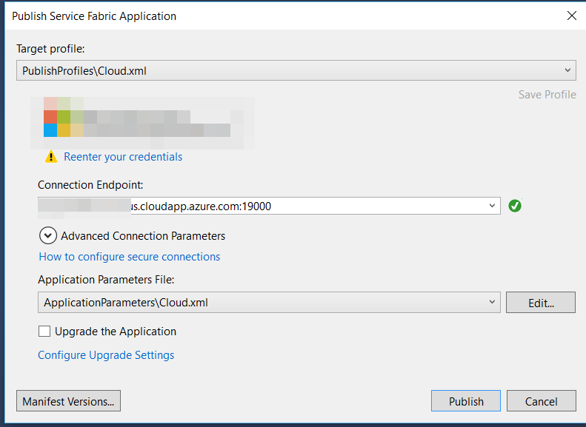

1. Select your Connection Endpoint.
2. Click Publish.

**Note**: Publishing to the hosted Service Fabric Cluster takes about 5 minutes. It follows the same steps as a local publish step with an alternate configuration. The Visual Studio output window keeps you updated of progress.

1. From the Visual Studio output window, validate that the deployment has completed with success.

### Task 2: Test an order from the cluster

In this task, you will test an order against your application deployed to the hosted Service Fabric Cluster.

#### Tasks to complete

1. From the browser, navigate to the Swagger endpoint for the Web API exposed by the hosted Service Fabric cluster. The URL is made of: http://<your-cluster-name>.<your-region>.cloudapp.azure.com:8082/swagger/ui/index. For example,

<http://contosoeventssf-SUFFIX.eastus.cloudapp.azure.com:8082/swagger/ui/index>

1. Expand the Orders API and expand the POST /api/orders API operation as shown in the following screen shot.

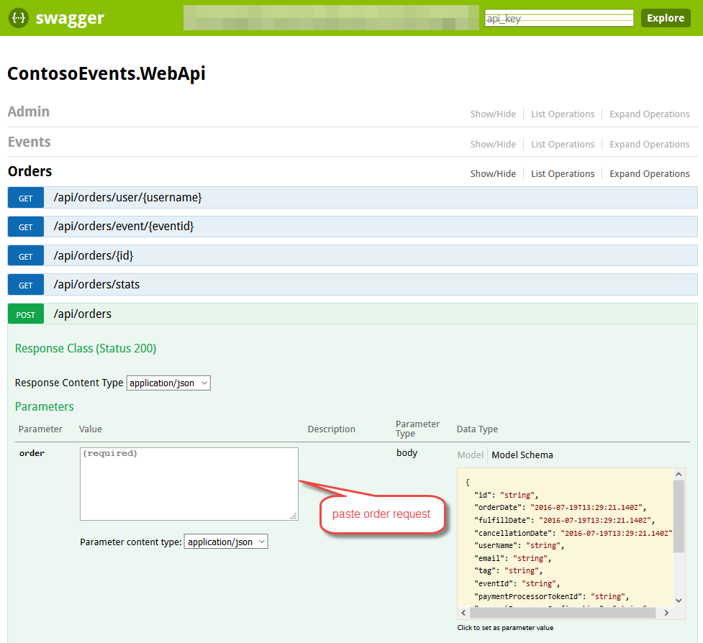

1. Copy and paste the following JSON to in the parameter text area, then click ‘Try it out’.

{

"UserName": "johnsmith",

"Email": "john.smith@gmail.com",

"Tag": "Manual",

"EventId": "EVENT1-ID-00001",

"PaymentProcessorTokenId": "YYYTT6565661652612516125",

"Tickets": 3

}



1. This should return successfully with HTTP 200. The response includes a unique order id that clients could use to track the order.



1. Verify that the order has persisted to the Orders collection. From the Azure Portal, find your DocumentDB account previously created. Perform a query as you did previously to verify the order exists in the collection.



## Exercise 4: API Management

Duration: 15 minutes

In this exercise, you will configure the API Management service.

### Task 1: Import API

In this task, you will import the Web API description to your API Management service to create an endpoint.

#### Tasks to complete

1. From the Azure Portal select API Management and select the service you created earlier.
2. From the API Management blade, select Publisher portal.
3. Select APIs.

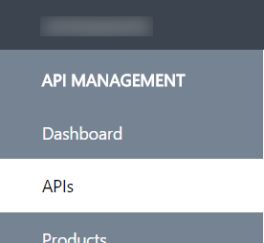

1. Click Import API.

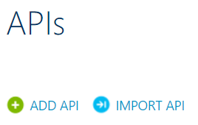

1. Select From URL.
2. Provide the URL shown in the Swagger endpoint of the Service Fabric deployed Web API.

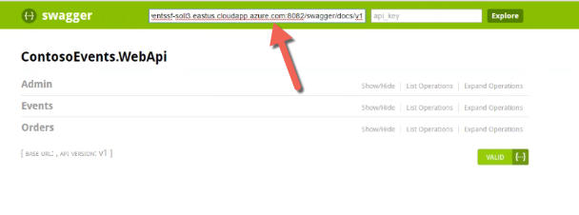

1. Set the Specification format to Swagger.
2. Set the Web API URL suffix to ‘events’ as shown in the following screen shot. Take note of what the URL will be as shown in the screenshot, such as <https://contosoeventsSUFFIX.azure-api.net/events>/. You will use this URL in your web site configuration in the next exercise.
3. Include product Unlimited.

**Note:** You would typically create a new product for each environment in a scenario like this one. For example Development, Testing, Acceptance and Production (DTAP) and issue a key for your internal application usage for each environment, managed accordingly.

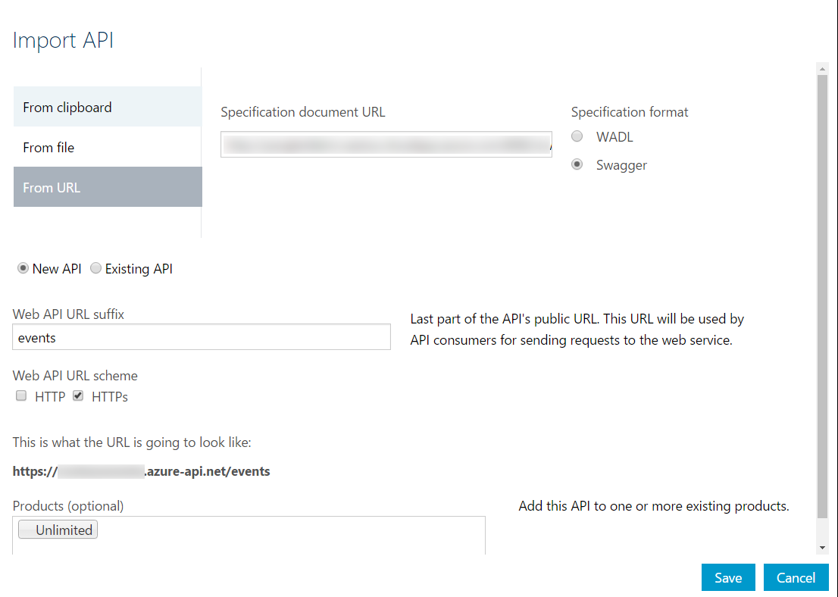

1. Click Save.
2. You will see your API listed under APIs.

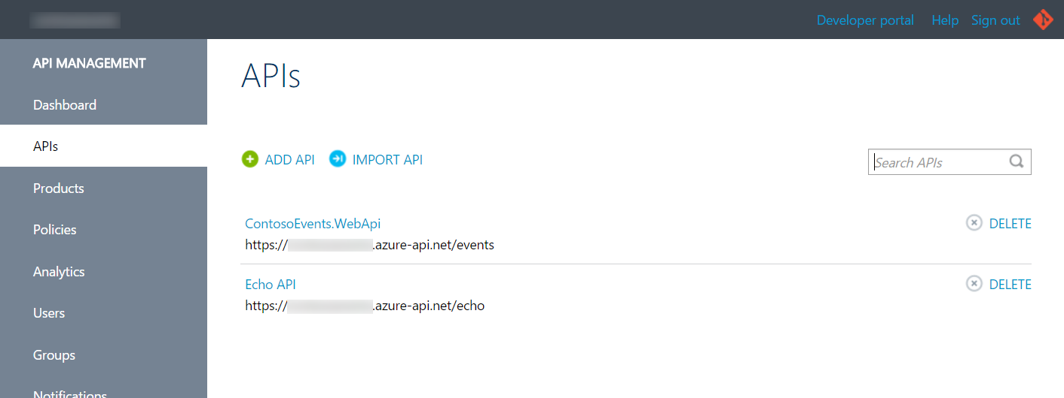

### Task 2: Retrieve the user subscription key

In this task, you will retrieve the subscription key for the client applications to call the new API Management endpoint.

1. Return to the API Management blade. Select the publisher portal link.

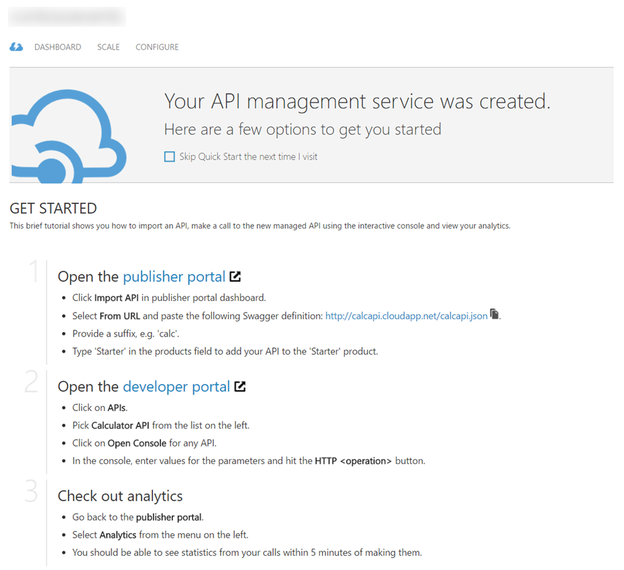

1. From the publisher portal, click the Developer portal menu item to navigate to the Developer portal as an Administrator with rights to complete the following steps.
2. Click the Administrator menu and then click Profile.

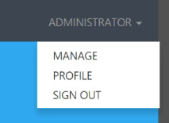

1. Click Show for the Primary Key of the Unlimited subscription to reveal it.

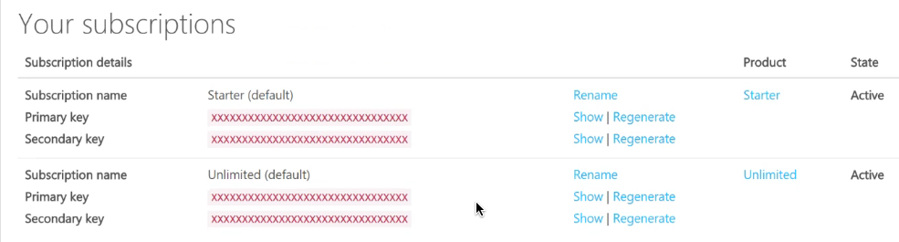

**Note:** You would typically create a new product subscription for each environment in a scenario like this one. For example Development, Testing, Acceptance and Production (DTAP) and issue a key for your internal application usage for each environment, managed accordingly.

1. Save this key for next steps.

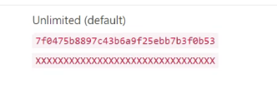

1. You now have API Management application key you will need to configure the Function App settings for order load test simulation.

### Task 3: Configure the Function App with the API Management key

In this task, you will provide the API Management key in a setting for the Function App so it can reach the Web API through the API Management service.

1. From the Azure Portal, browse to the Function App.
2. You will create an application setting for the function to provide it with the API Management consumer key. Select Function app settings.

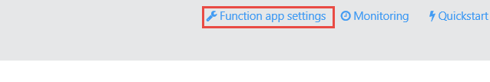

Under the Develop header, select Configure app settings.

1. Scroll down to find the section where you place app settings and add the key ‘contosoeventsapimgrkey’. For the value, place the key you saved for API Management.
2. Save your settings.

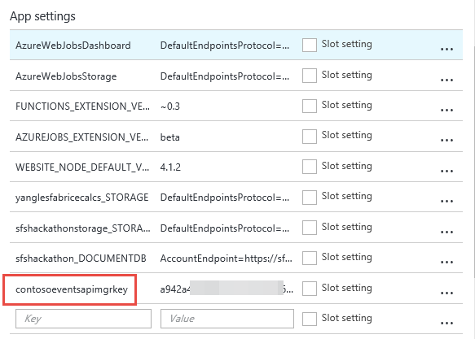

1. You will be able to issue a load test from the website in Exercise 8, and see that orders have been processed through the function – because it will have successfully called the API and you will see results in the load test status page.

## Exercise 5: Configure and publish the web application

Duration: 15 minutes

In this exercise, you will configure the website to communicate with the API Management service, deploy the application, and create an order.

### Task 1: Configure the Web App settings

In this task, you will update configuration settings to communicate with the API Management service. You will be guided through the instructions to find the information necessary to populate the configuration settings.

1. Within Visual Studio Solution Explorer, expand the Web folder, then expand the ContosoEvents.Web project, and open Web.config. You will update these appSettings in this file:

<add key="apimng:BaseUrl" value="" />

<add key="apimng:SubscriptionKey" value="" />

#### API Management

1. For the apimng:BaseUrl enter the base URL of the API you created in API Management such as <https://contosoeventsSUFFIX.azure-api.net/events/>.

**Note**: Make sure to include the closing / or the exercise will not work.

1. For the apimng:SubscriptionKey enter the subscription key you revealed in API Management developer portal.
2. You should have values for two the API Management app settings.

### Task 2: Running the Web App and creating an order

In this task, you will test the Web application calls to API Management by creating an order through the UI.

1. Using Solution Explorer in Visual Studio, open the Web folder.
2. Right click the ContosoEvents.Web project, select Debug, and then Start new instance.
3. When the application launches you will see the website home page as shown in the following screen shot.



1. Note the event presented on the home page has an Order Tickets Now button. Click that to place an order.
2. Choose the number of tickets for the order, and then scroll down to see the billing fields.

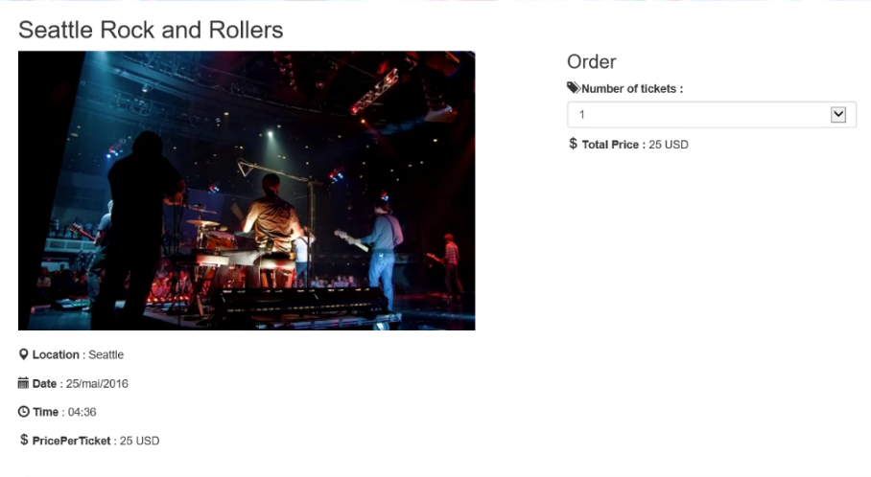

1. Since you have not yet integrated Azure Active Directory B2C, the application does not know who you are. You will have to enter the empty fields for your email, first name, and last name.

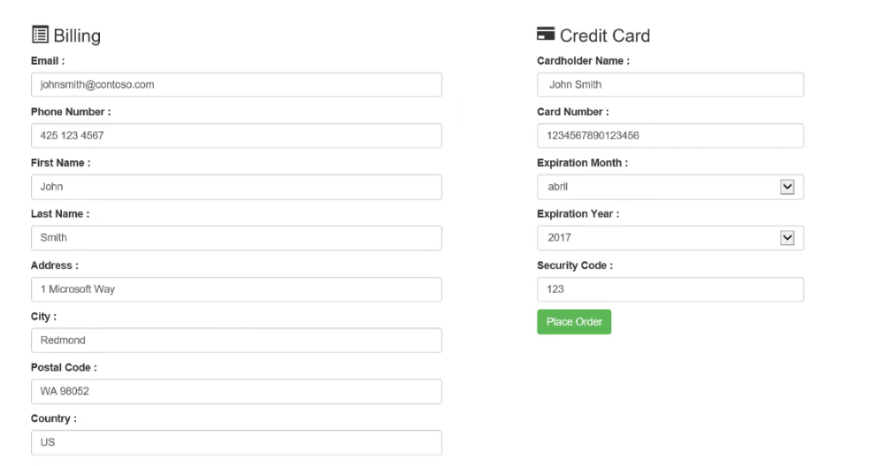

1. Click Place Order.
2. Once the order is queued for processing, you will be redirected to a results page as shown in the following screen shot. It should indicate Success and show you the order id that was queued as confirmation.

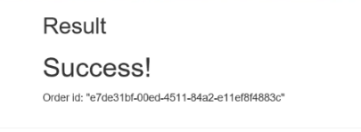

### Task 3: Publish the web app

In this task, you will publish the Web application to Azure.

1. From Solution Explorer, right-click ContosoEvents.Web and select Publish. Select Microsoft Azure App Service from the Profile tab in the dialog and click Next.

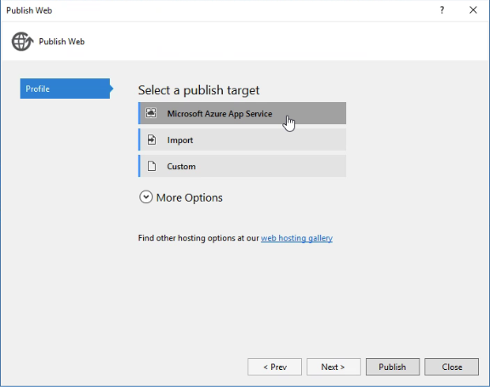

1. You may be prompted to log in to your Microsoft Account with access to the subscription where you created the resources for this hackathon. After logging in you can select the subscription in the App Service screen.
2. From the list below, expand the Resource Group you created previously and select the Web App contosoeventsweb-SUFFIX. Click OK.

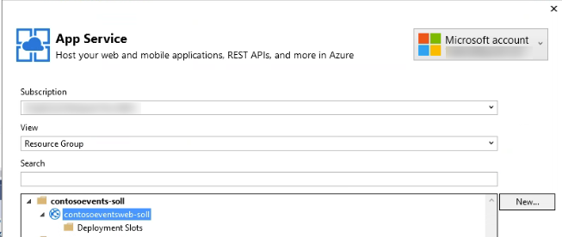

1. On the Connection tab, accept the defaults presented and click Validate Connection to avoid delays in publishing should there be a problem.
2. Once validated, click Next.

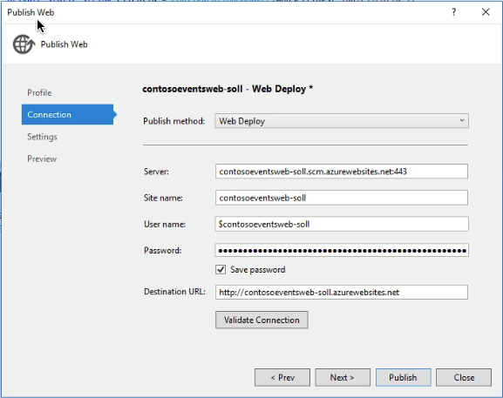

1. From the Settings tab, leave the default settings and click Publish.

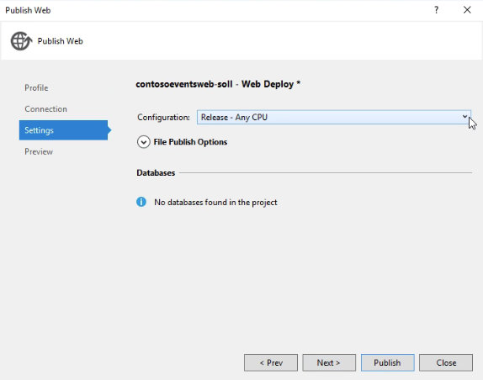

1. When publishing is complete, your browser will launch and navigate to the deployed Web app home page. You can optionally submit another order to validate functionality works as in Task 2.

## Exercise 6: Upgrading

Duration: 30 minutes

In this task, you will make changes to the code and deploy an update to the application to enhance functionality. Specifically, the update addresses the area of concern related to changes in the ticket order model and the impact on the system as a whole.

This task will illustrate the mechanism that Service Fabric provides for upgrading an application in production.

### Task 0: How upgrade works

In Service Fabric, deployments can be either regular or upgrade. A regular deployment erases any previous deployment data while the upgrade deployment preserves it. There are advantages to upgrades:

* Stateful service data will not be lost during upgrade
* Availability remains during the upgrade

The following figure illustrates the deployment hierarchy:



If you set the upgrade mode to Monitored, Service Fabric will be in full control of the upgrade process. There is a configurable time to wait after the upgrade has finished before Service Fabric evaluates the health of the application. This value defaults to 600 seconds.

### Task 1: Update an actor state

Currently, the TicketOrderActor does not have a status property to make it easier to check on the actor order status quickly. In this task, you will modify the Ticket Order State model to add a new status property.

#### Tasks to complete

1. Using Visual Studio, open TicketOrder.cs in the ContosoEvents.Models project underneath the Common folder.
2. Edit the TicketOrder type to include a status field based on an Enum. Uncomment all TODO: Exercise 6 – Task 1 – there are **two** places as shown below:

//TODO: Exercise 6 - Task 1

[DataMember]

public OrderStatuses Status { get; set; }

and

//TODO: Exercise 6 - Task 1

public enum OrderStatuses

{

Fufilled,

TicketsExhausted,

CreditCardDenied,

Cancelled,

Invalid

}

1. Using Visual Studio, open TicketOrderActor.cs in the ContosoEvents.TicketOrderActor project.
2. Edit the TicketOrderActor to add the new order status. Uncomment all TODO: Exercise 6 – Task 1. The change will uncomment several lines that set the new Status field to one of the OrderStatuses enumeration values. Be sure to find all or the following comments:

//TODO: Exercise 6 - Task 1

state.Status = OrderStatuses.Invalid;

//TODO: Exercise 6 - Task 1

state.Status = OrderStatuses.Fufilled;

//TODO: Exercise 6 - Task 1

state.Status = OrderStatuses.CreditCardDenied;

//TODO: Exercise 6 - Task 1

state.Status = OrderStatuses.TicketsExhausted;

//TODO: Exercise 6 - Task 1

state.Status = OrderStatuses.Invalid;

//TODO: Exercise 6 - Task 1

state.Status = OrderStatuses.Cancelled;

1. After adding this field, the actor will now save it with each ticket order.
2. After making this change, compile the solution and verify that there are no errors.

### Task 2: Perform a smooth upgrade

In this task, you will configure settings for the Service Fabric application to perform an upgrade.

1. From Solution Explorer, right-click the Service Fabric application node, ContosoEventsApp, and select Publish.
2. In the Public Service Fabric Application dialog, select Cloud.xml for the target profile.
3. Check Upgrade the Application.

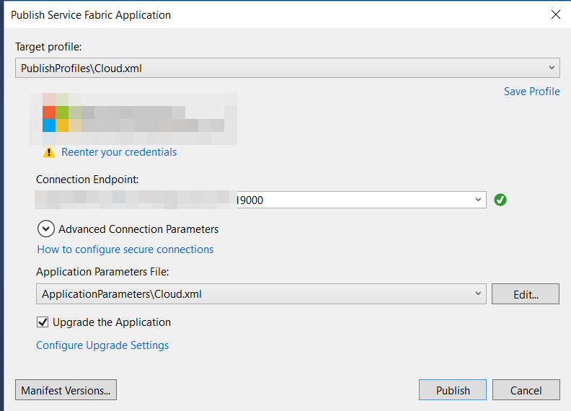

1. Click Configure Upgrade Settings. Select ‘Monitored’ for the upgrade mode as shown in the following screen shot and click OK.

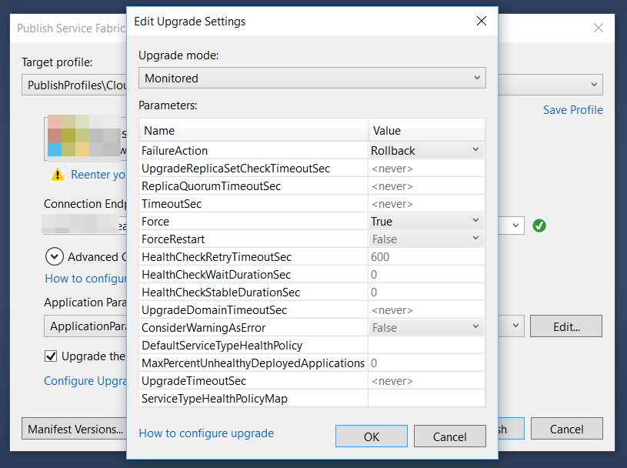

1. From the Publish Service Fabric Application dialog, click Manifest Versions.
2. Change the TicketOrderActorPkg\Code New Version to 1.1.0. This change will force the actor package and the app to change to 1.1.0 as well.
3. Click Save.

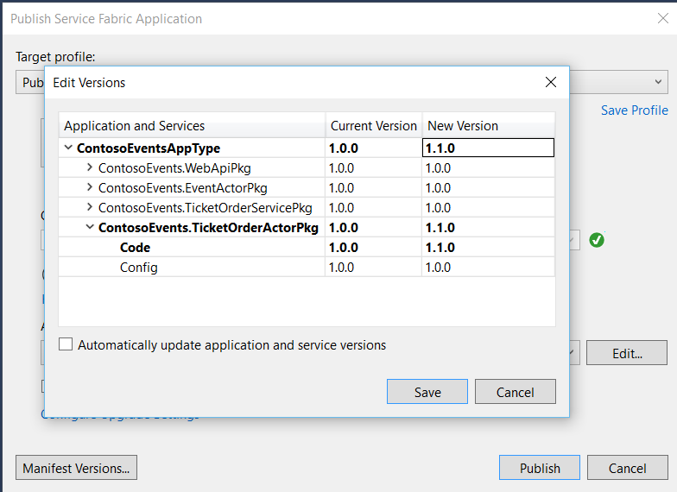

1. Now that the upgrade configuration is set, click Publish.
2. Observe the Visual Studio Output window going through the upgrade process.

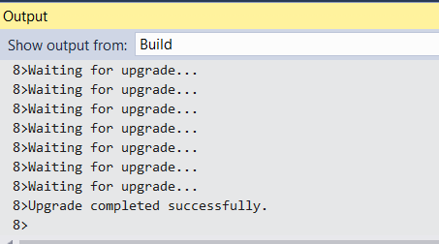

1. Navigate to the Service Fabric Explorer for the deployment using your URL, something like:

http://contosoeventssf-SUFFIX.eastus.cloudapp.azure.com:19080/Explorer/index.html

1. It will show the app being upgraded one upgrade domain at a time.

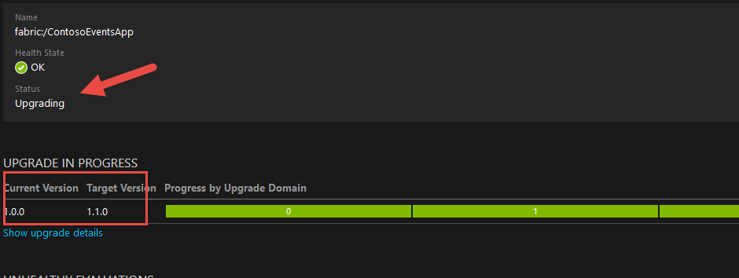12. When the upgrade is complete, from Service Fabric Explorer observe the new application version number.

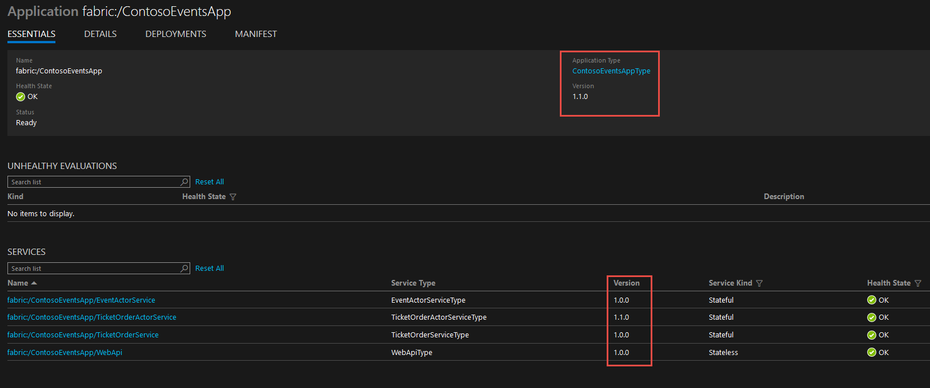

### Task 3: Submit a new order

Now that the upgrade is completed successfully, you will submit a new order and make sure that the newly submitted order has the extended state.

1. This time, you will post an order using the Web API for the deployed service. The order can be something like this:

{

"userName": "testupgrade",

"email": "test.upgrade@gmail.com",

"eventId": "EVENT1-ID-00001",

"paymentProcessorTokenId": "ggashwh565-uiewuu87-ujdsk",

"tickets": 3

}

1. Access the Swagger UI for your published Service Fabric Web API at a URL that looks like this:

<http://contosoeventssf-SUFFIX.eastus.cloudapp.azure.com:8082/swagger/ui/index>

1. Access the Order API and select POST /api/orders. From there you can submit a new order:

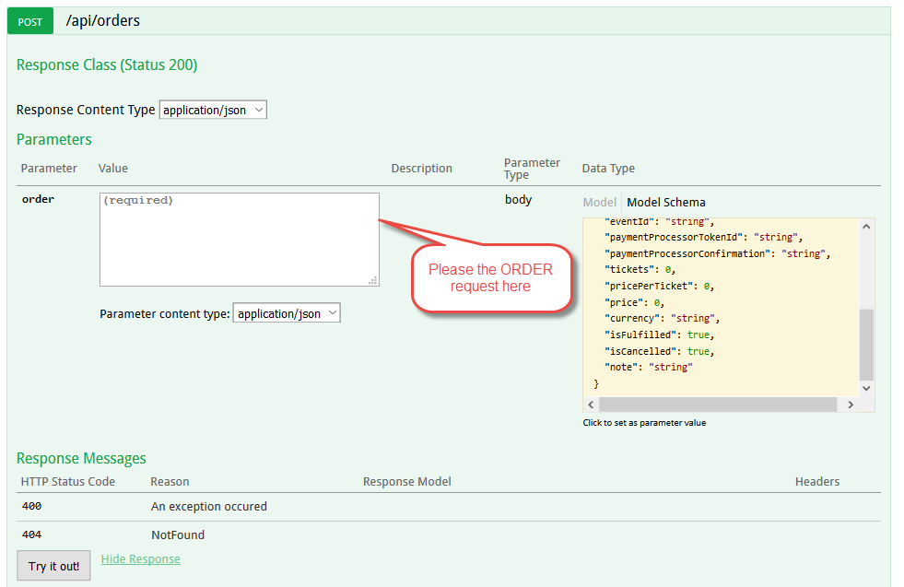

1. Once you get back a 200 response code, the order id will be returned:

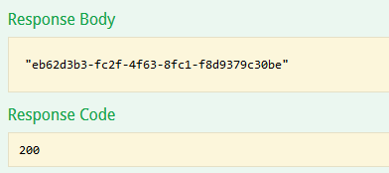

1. From the Azure Portal, navigate to your DocumentDB account.
2. Go to DocumentDB query explorer and query for the order id to see the new extended state actually persisted to the database:

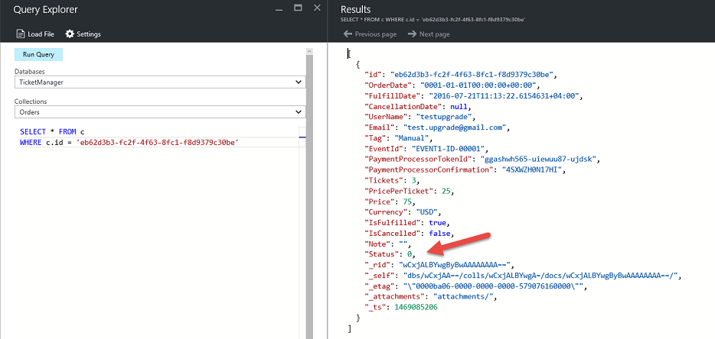

## Exercise 7: Rollback

Duration: 30 minutes

In this exercise, you will deploy an update that causes issues with the application, and will trigger an automatic rollback of the deployment. This exercise will illustrate the mechanism Service Fabric provides for preserving application health and availability in production.

### Task 1: Add health checks

In this task, you will add code to produce health checks that force the monitored upgrade to roll back to the original version of the service.

#### Tasks to complete

1. In Visual Studio, open TicketOrderService.cs located in the ContosoEvents.TicketOrderService project.
2. Locate TODO: Exercise 7 – Task 1 and uncomment:

//TODO: Exercise 7 - Task 1

this.HealthReporterService.SendReportForService(HealthState.Error, "Simulated Error");

1. Compile the code to ensure there are no issues with the changes.

### Task 2: Perform a troubled upgrade

In this task, you will perform an upgrade and watch a rollback of the upgrade.

#### Tasks to complete

1. From Solution Explorer, right-click the Service Fabric application node, ContosoEventsApp, and select Publish.
2. From the Publish Service Fabric Application dialog, click Manifest Versions.
3. Change the TicketOrderServicePkg\code New Version to 1.1.0. This will also require that the service package be changed to 1.1.0 and the application to 1.2.0.
4. Click Save.

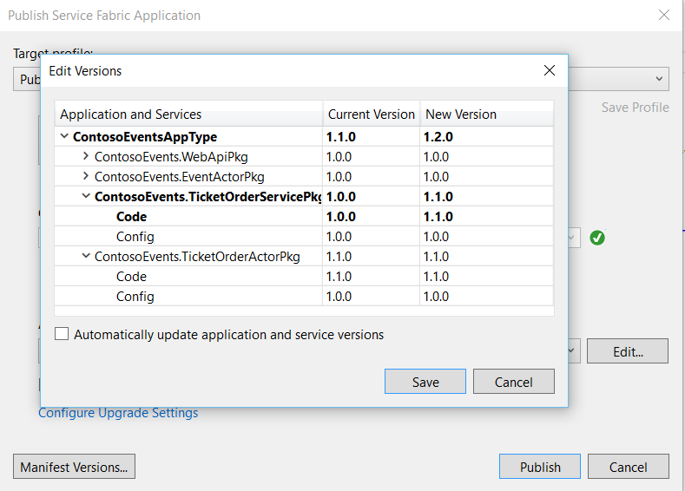

1. Click Publish and return to Service Fabric Explorer.
2. Observe the time it is taking to upgrade in Visual Studio and the errors that are now occurring in Service Fabric Explorer.
3. Notice that the simulated error message ‘Simulated error’ appears in the event as shown in the following screen shot:

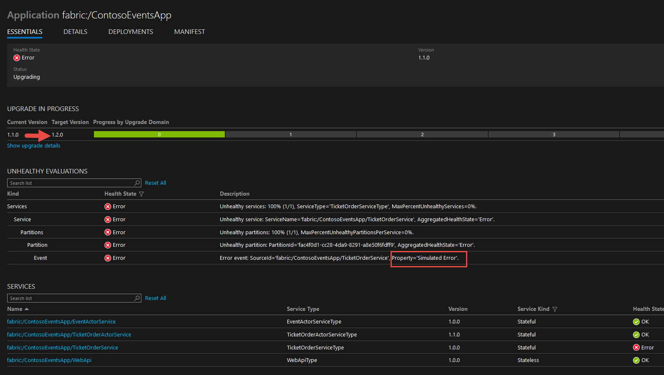

**Note:** Service Fabric is attempting to upgrade and it is waiting for the service to report healthy status. Because this will not happen, eventually Service Fabric rolls back the upgrade.

1. In the meantime, observe that the application is still responsive. In the Swagger UI for your Service Fabric Web API, access the Events API and select GET /api/events to see a list of events as shown in the following screen shot:

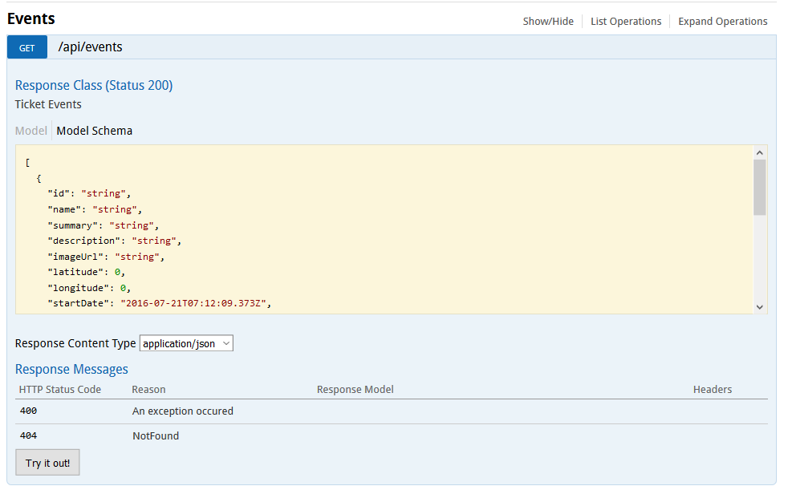

1. So that you do not forget, return to the code and re-comment the failure report so that you can do the next exercise without rollback!

//TODO: Exercise 7 - Task 1

//this.HealthReporterService.SendReportForService(HealthState.Error, "Simulated Error");

1. Look at the Visual Studio output window and note that after some time 600 milliseconds (by default, and this is configurable) Service Fabric gives up on the app and rolls back the upgrade as shown in the following screen shot:

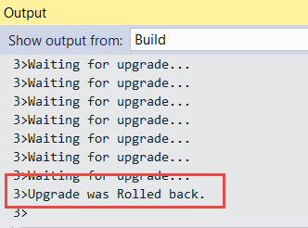

1. Return to Service Fabric Explorer note that version 1.2.0 (that contained the simulated error) was rolled back to version 1.1.0 the version that was running in your cluster before the attempted upgrade.
2. Also, note that the error remains until it is time to live expires or it is replaced by another health state. Until then, the unhealthy state will remain in the cluster but the cluster will be running normally. You can proceed without clearing this for now.
3. The subsequent exercises (i.e. 8 and beyond) will be executed using version 1.1.0 and while the cluster shows unhealthy state. You can ignore this for now.

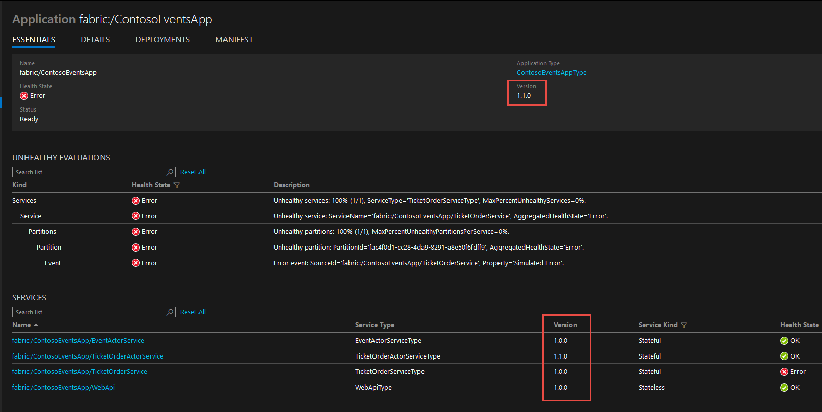

1. Optionally, from the Swagger endpoint for the deployed application, you can request health statistics at the following relative URL: /api/admin/applicationhealth.

## Exercise 8: Load testing

Duration: 15 minutes

In this exercise, you will perform a load tests against the Service Fabric Cluster and observe how messages are distributed across partitions.

### Task 1: Simulate a 50 order request

In this task, you will simulate a load test of 50 orders against the cluster using the Web application to submit the load test and monitor partitions.

#### Tasks to complete

1. Navigate to the published Web application at a URL like <https://contosoeventsweb-SUFFIX.azurewebsites.net>.
2. Click the Load Test menu. Optionally give a new name to the tag for tracking. Set load to 50 requests. Click Start Load Test.

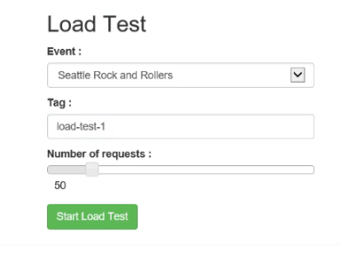

1. Navigate to the Load Test Status menu. It shows you the partitions that were created for the ticket order service (reliable queue).

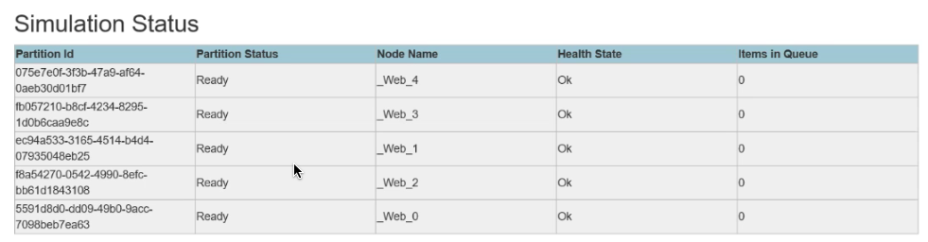

1. While the load test is running, refresh this page and watch the changes to the Items in queue across partitions. It will fill while processing completes and then eventually drain.
2. After a few minutes you will see that the queues are drained and the orders were processed.

**Note**: If you still have more time, run this again with additional iterations progressively such as 100, 150, 200, 250. Or, take a look at Exercise 9 which takes you through a much more comprehensive load test and partition analysis process using the API endpoint.

## BONUS Exercise 9: Load testing w/ partitions

**Note: If you completed the other work in good time and still have another 50 minutes free, have some load testing and partitioning fun! Otherwise, skip to cleanup.**

Duration: 50 minutes

In this task, you will perform several load tests against the Cluster using different partitions. This experimentation is crucial to get an idea of how many partitions you will really need. It is important to note that the number of partitions in your service cannot be changed after you have created the service. The main measure you are going to rely on is the average number of seconds it takes an order to be processed.

### Task 1: Setting up for load testing

In this task, you will clean the existing orders from the DocumentDB so you can start with clean slate. This step is optional but because we are going to rely on reporting about orders in the database, it is much better to keep in the database only the orders that were simulated for load testing.

#### Tasks to complete

1. In the Swagger UI for your Service Fabric Web API, please access the admin APIs DELETE /api/admin/orders and issue the API. When you get back a 200-response code, the orders will have been deleted from the DocumentDB.

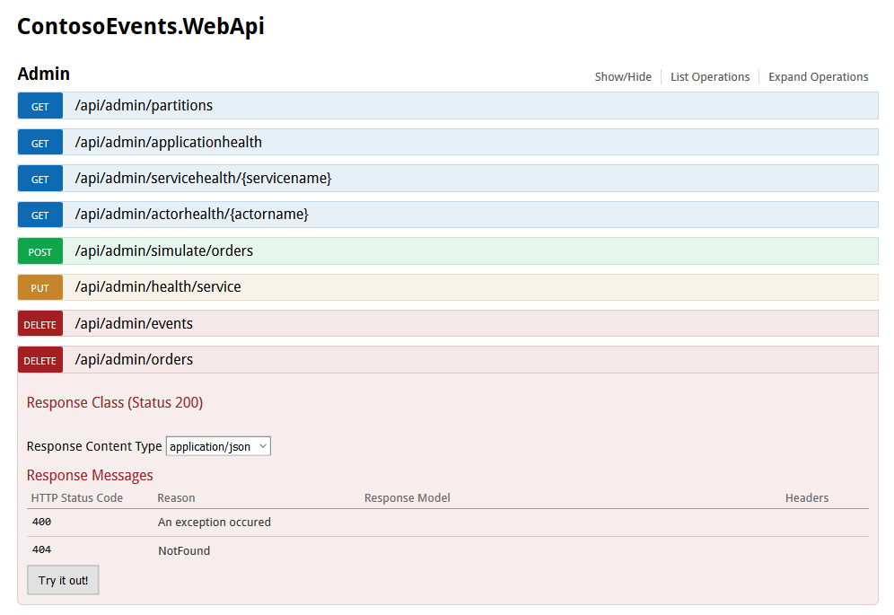

1. Because you have previously performed an upgrade to the Service Fabric application, and we want to play with partition sizes in this exercise, you will unprovision the application type using Service Fabric Explorer. Navigate to the explorer.
2. Delete the application.

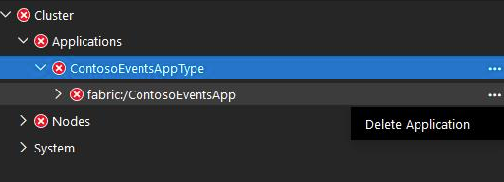

1. Unprovision the application type.

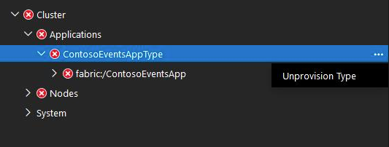

1. In the tasks that follow in this exercise you will not be upgrading when you publish the application. You will be re-publishing. Make sure Upgrade the application checkbox is unchecked each time you publish.

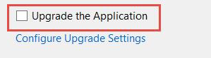

1. Service Fabric Explorer shows no application types or applications deployed.
2. You can verify from DocumentDB Orders Document Explorer that there are no more orders in the database:

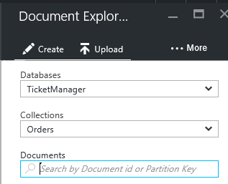

### Task 2: Using the current partition count, simulate 100 orders

In this task, you will simulate a load test against the Cluster using the current partition count (that is, 5) of the Ticket Order Service.

#### Tasks to complete

1. Using the Service Fabric Web API Swagger UI, please issue a POST request against /api/admin/simulate/orders

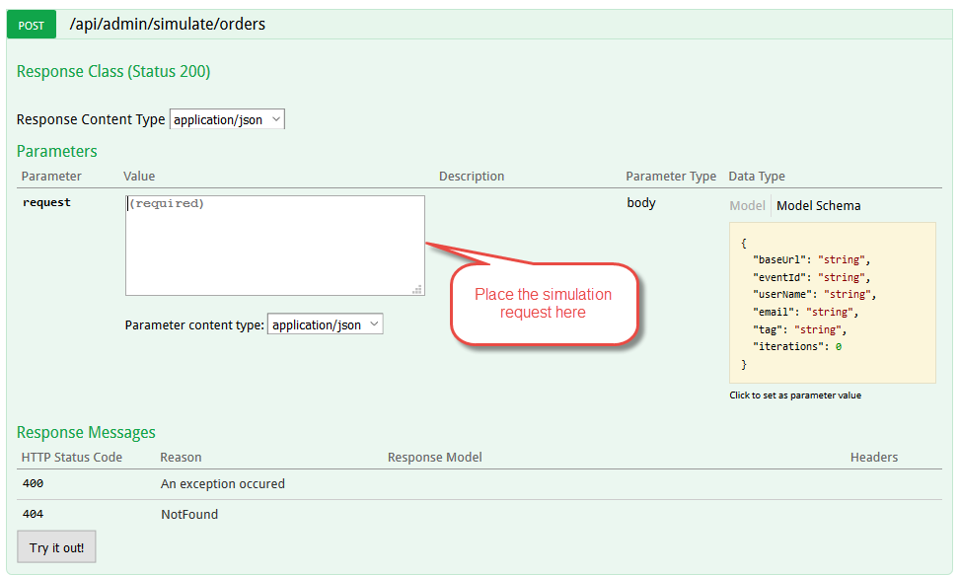

A sample simulation order request can be formed as follows. The tag identifies the simulation run so we can report on it later

{

"baseUrl": "http://<your-cluster-name>.<your-region>.cloudapp.azure.com:8082",

"eventId": "EVENT1-ID-00001",

"userName": "tester",

"email": "load.tester@gmail.com",

"tag": "partitions-5-100",

"iterations": 100

}

1. As the simulation request is processed, please issue a GET request against /api/admin/partitions to see how the different partitions are functioning. This returns partition info, health, and the number of items in each partition queue. You should notice that the queues fill up with order requests and are drained.

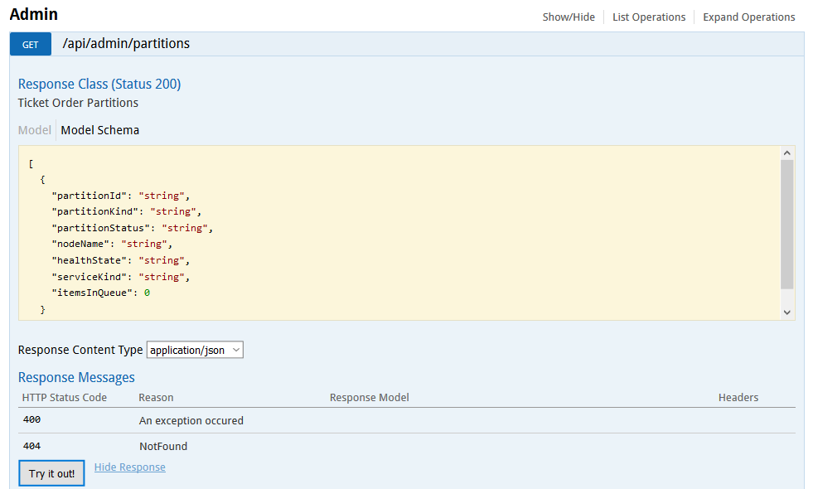

1. The response might look like this.

[

{

"partitionId": "856b5048-bb35-45fb-b804-f91f4fb48ccf",

"partitionKind": "Int64Range",

"partitionStatus": "Ready",

"nodeName": "_Node_4",

"healthState": "Ok",

"serviceKind": "Stateful",

"itemsInQueue": 10

},

{

"partitionId": "f912eb50-bf89-4be9-8d39-61dfc3b69a01",

"partitionKind": "Int64Range",

"partitionStatus": "Ready",

"nodeName": "_Node_3",

"healthState": "Ok",

"serviceKind": "Stateful",

"itemsInQueue": 8

},

{

"partitionId": "acefa86e-c57c-4a84-b6cb-230d6c8a9e23",

"partitionKind": "Int64Range",

"partitionStatus": "Ready",

"nodeName": "_Node_2",

"healthState": "Ok",

"serviceKind": "Stateful",

"itemsInQueue": 6

},

{

"partitionId": "2c6c7dd9-8ff4-4303-bd1f-fb48ed51952d",

"partitionKind": "Int64Range",

"partitionStatus": "Ready",

"nodeName": "_Node_1",

"healthState": "Ok",

"serviceKind": "Stateful",

"itemsInQueue": 6

},

{

"partitionId": "1da411e7-577f-4440-a3ab-257962051b0c",

"partitionKind": "Int64Range",

"partitionStatus": "Ready",

"nodeName": "_Node_0",

"healthState": "Ok",

"serviceKind": "Stateful",

"itemsInQueue": 0

}

]

1. Wait for 2-3 minutes until to make sure that queues are drained and that orders are processed before completing this task.

### Task 3: Using a partition count of 10, simulate 100 orders

In this task, you will repeat the same load test you performed in Task 2 but using a partition count of 10.

1. Change the service and actor partition count to 10 in the Cloud.xml Application Parameters file.
2. Double-click the document in Visual Studio and make the following changes:

<Parameter Name="TicketOrderService_PartitionCount" Value="10" />

<Parameter Name="TicketOrderService_MinReplicaSetSize" Value="3" />

<Parameter Name="TicketOrderService_TargetReplicaSetSize" Value="3" />

<Parameter Name="WebApi_InstanceCount" Value="5" />

<Parameter Name="TicketOrderActorService_PartitionCount" Value="10" />

<Parameter Name="EventActorService_PartitionCount" Value="1" />

1. Using Visual Studio Publish command, redeploy the app to the cluster (as shown in a previous task).
2. Repeat the same test load you did in Task 2 but with a different tag:

{

"baseUrl": "http://<your-cluster-name>.<your-region>.cloudapp.azure.com:8082",

"eventId": "EVENT1-ID-00001",

"userName": "tester",

"email": "load.tester@gmail.com",

**"tag": "partitions-10-100",**

"iterations": 100

}

1. Wait for 2-3 minutes until to make sure that queues are drained and that orders are processed before completing this task.

### Task 4: Using a partition count of 15, simulate 100 orders

In this task, you will repeat the same load test you performed in Task 2 but using a partition count of 15.

1. Change the service and actor partition count to 15 in the Cloud.xml Application Parameters file.
2. Double-click the document in Visual Studio and make the following changes:

<Parameter Name="TicketOrderService_PartitionCount" Value="15" />

<Parameter Name="TicketOrderService_MinReplicaSetSize" Value="3" />

<Parameter Name="TicketOrderService_TargetReplicaSetSize" Value="3" />

<Parameter Name="WebApi_InstanceCount" Value="5" />

<Parameter Name="TicketOrderActorService_PartitionCount" Value="15" />

<Parameter Name="EventActorService_PartitionCount" Value="1" />

1. Using the Visual Studio Publish command, redeploy the app to the cluster (as shown in a previous task).
2. Repeat the same test load you did in Task 2 but with a different tag:

{

"baseUrl": "http://<your-cluster-name>.<your-region>.cloudapp.azure.com:8082",

"eventId": "EVENT1-ID-00001",

"userName": "tester",

"email": "load.tester@gmail.com",

**"tag": "partitions-15-100",**

"iterations": 100

}

1. Wait for 2-3 minutes until to make sure that queues are drained and that orders are processed before completing this task.

### Task 5: Using a partition count of 20, simulate 100 orders

In this task, you will repeat the same load test you performed in Task 2 but using a partition count of 20.

1. Change the service and actor partition count to 20 in the Cloud.xml Application Parameters file.
2. Double-click the document in Visual Studio and make the following changes:

<Parameter Name="TicketOrderService_PartitionCount" Value="20" />

<Parameter Name="TicketOrderService_MinReplicaSetSize" Value="3" />

<Parameter Name="TicketOrderService_TargetReplicaSetSize" Value="3" />

<Parameter Name="WebApi_InstanceCount" Value="5" />

<Parameter Name="TicketOrderActorService_PartitionCount" Value="20" />

<Parameter Name="EventActorService_PartitionCount" Value="1" />

1. Using Visual Studio Publish command, redeploy the app to the cluster (as shown in a previous task).
2. Repeat the same test load you did in Task 2 but with a different tag:

{

"baseUrl": "http://<your-cluster-name>.<your-region>.cloudapp.azure.com:8082",

"eventId": "EVENT1-ID-00001",

"userName": "tester",

"email": "load.tester@gmail.com",

**"tag": "partitions-20-100",**

"iterations": 100

}

1. Wait for 2-3 minutes until to make sure that queues are drained and that orders are processed before completing this task.

### Task 6: Determine the performance variations among the different load tests

In this task, you will find out how each load test performed and plot the result.

#### Tasks to complete

1. Using the Service Fabric Web API Swagger UI, please issue a GET request against /api/orders/stats.

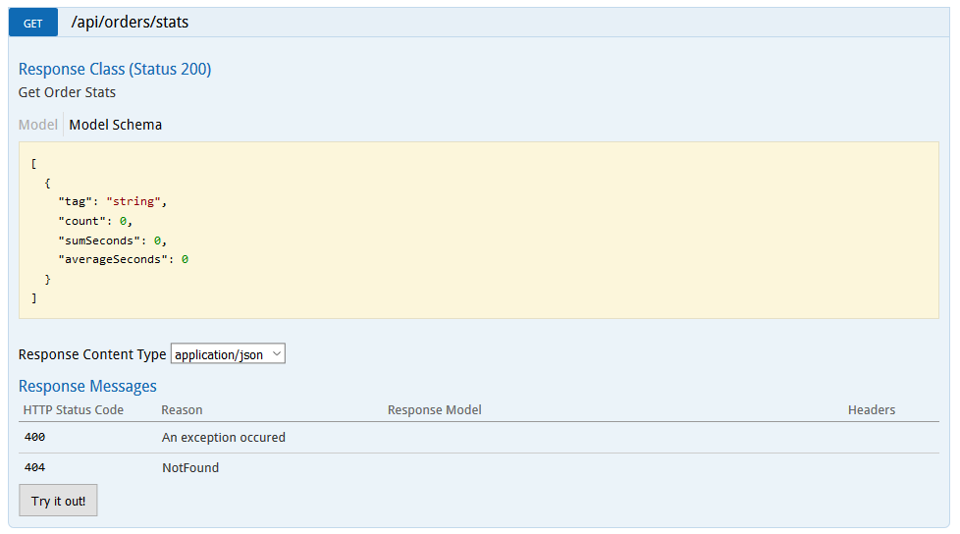

1. The command returns stats about each load test you performed in JSON that looks like this:

[

{

"tag": "partitions-5-100",

"count": 100,

"sumSeconds": 5723.255288899996,

"averageSeconds": 6.23255288899996

},

{

"tag": "partitions-10-100",

"count": 100,

"sumSeconds": 4988.4539887,

"averageSeconds": 5.529214151190473

},

{

"tag": "partitions-15-100",

"count": 100,

"sumSeconds": 4664.7163935999988,

"averageSeconds": 5.11790983999997

},

{

"tag": "partitions-20-100",

"count": 100,

"sumSeconds": 3245.5302888,

"averageSeconds": 4.82359205714286

}

]

1. Scale out the VMs count to 10, for example, in your cluster and repeat tasks 2, 3, 4, and 5. This step is out of scope and is shown here only to complete the picture.
2. Given the load test results for each Cluster configuration, produce an Excel sheet from the data you collected. A sample may look like this:



1. Armed with an average number of seconds it takes to process orders for different partition and VMs count, you are in a better situation to recommend a partition count for your application.

## BONUS Exercise 10: Secure the web application

**Note: If you completed the other work in good time and still have another 30 minutes do this exercise and integrate Azure Active Directory B2C with the application. Otherwise, skip to cleanup.**

Duration: 30 minutes

In this exercise, you will configure the Azure Active Directory B2C tenant and configure the Web front end to integrate with it for use login. Once all the settings are in place, you will be able to run the web site, register as a user, and login.

### Task 1: Configure the Azure Active Directory B2C

In this task, you will set up the Azure Active Directory B2C directory for your application to integrate with it.

#### Tasks to complete

1. From the Azure Portal browse to Azure B2C. Select it to navigate to the Azure AD B2C Settings blade.

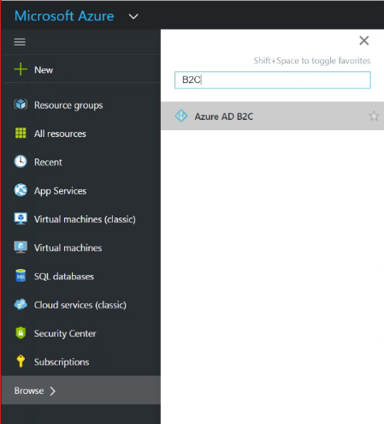

1. You should see the domain name you created earlier for your B2C directory.

**Note**: If you see an authorization error, you may have to select the directory from your profile menu and then repeat steps 1 and 2. Further, if your directory does not yet appear in the profile list, you should refresh the portal page to see it in the list.

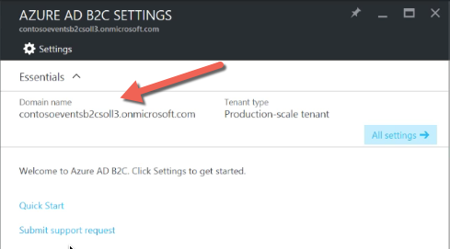

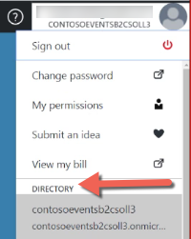

1. From the Settings blade, select Applications.

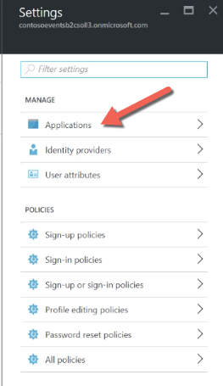

1. Click + Add.
2. Set the application name to WebApp.
3. Select Yes for include Web App / Web API.
4. Select Yes for Allow implicit flow.
5. Add a reply URL for local testing:

<https://localhost:44327/>

1. Add a reply URL for the hosted Web App as you named it, for example:

https://contosoeventsweb-SUFFIX.azurewebsites.net/

**Note**: Make sure to include the closing / or the configuration will not work.

1. Click Create.

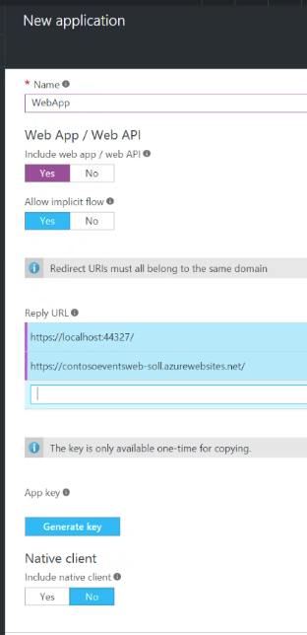

1. In the Settings blade, select Identity providers.
2. Select Username for Local accounts.
3. Click Save.

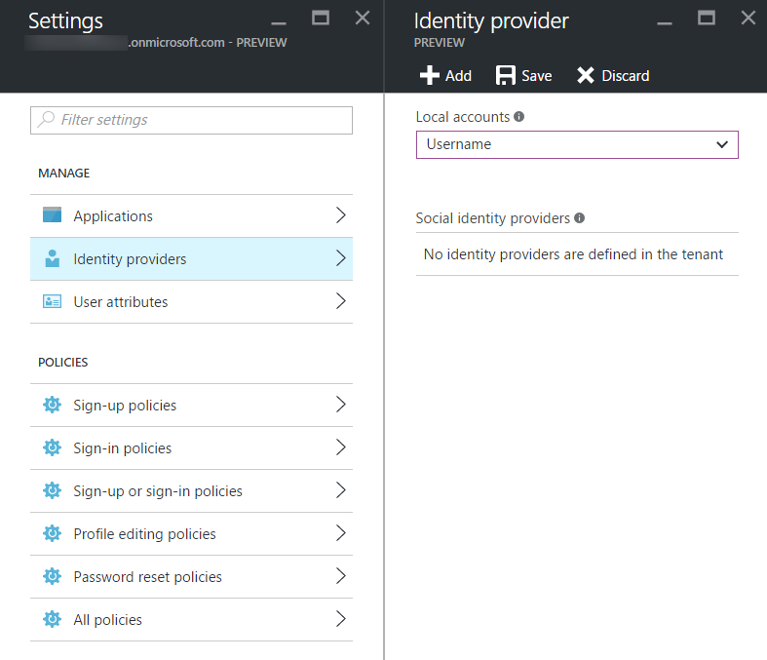

1. In the Settings blade, select Sign-up policies.
2. Click + Add.
3. Set the policy name to ‘signup’.

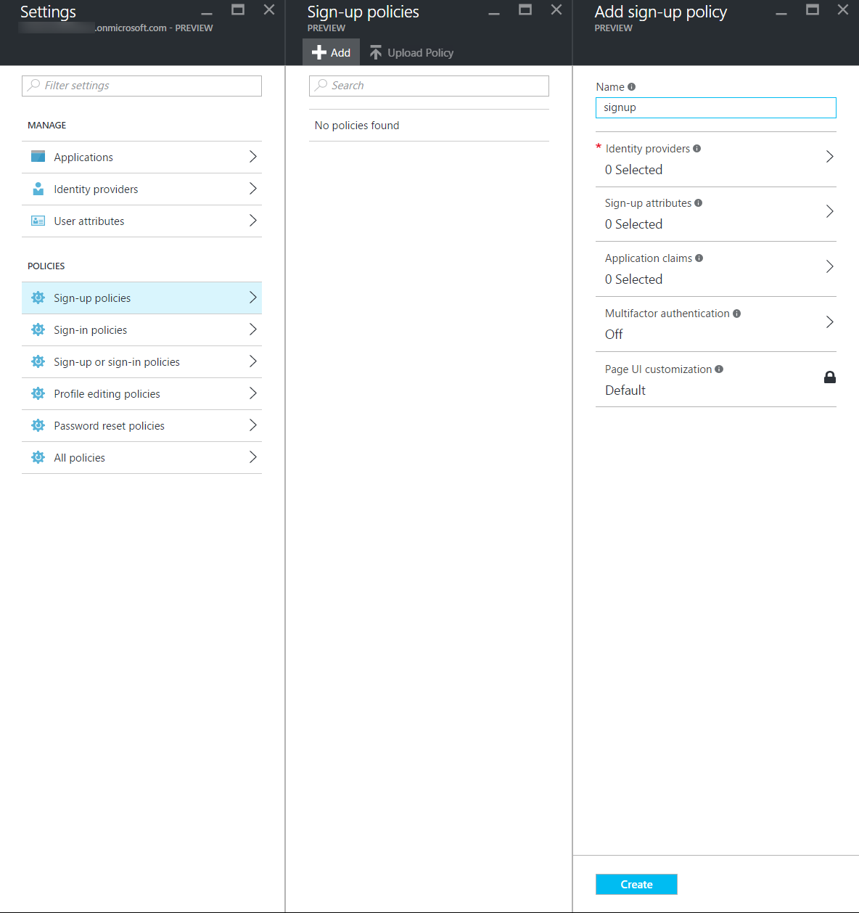

1. Select Identity providers.
2. Select User ID signup.
3. Click OK.

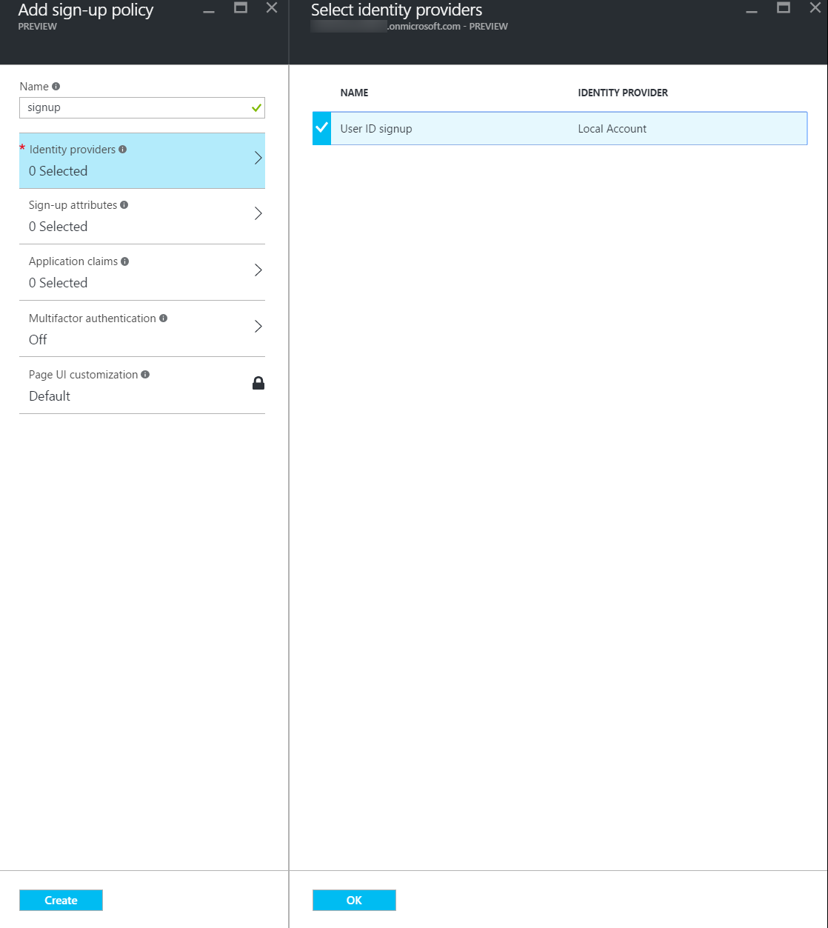

1. Select Sign-up attributes.
2. Select Email Address, Given Name, and Surname.
3. Click OK.

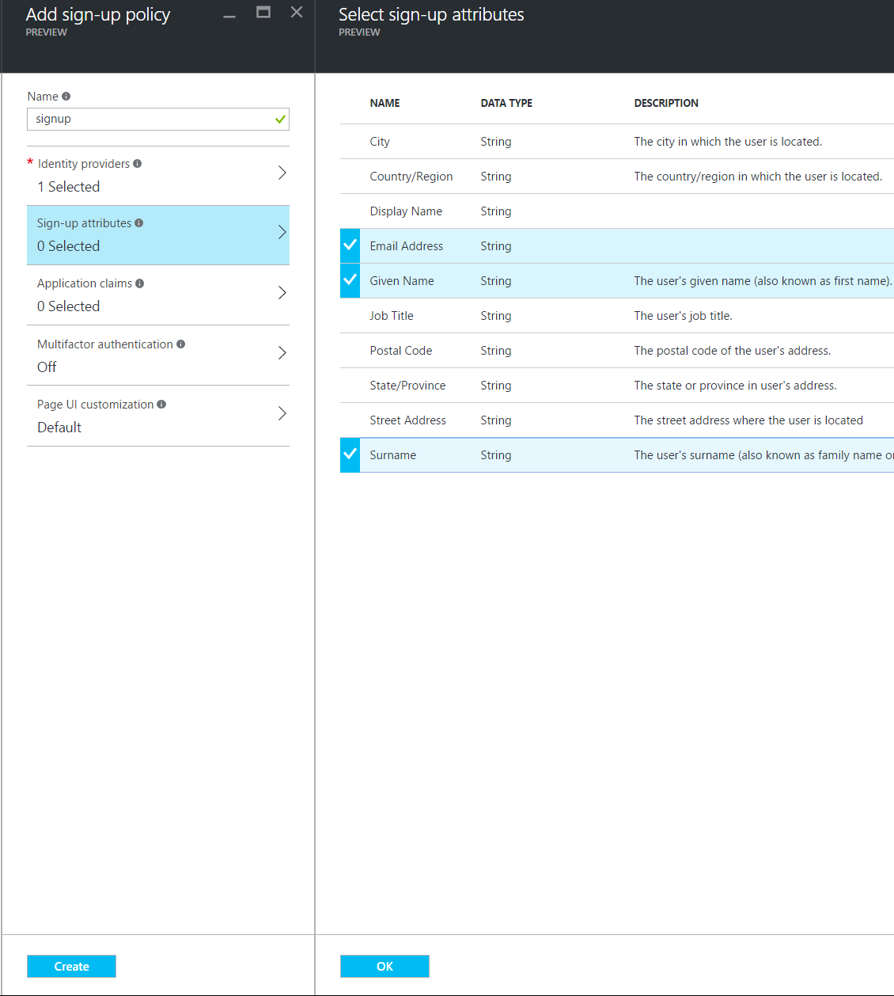

1. Select Application Claims.
2. Select Email Addresses, Given Name, Surname, and User’s Object ID.
3. Click OK.

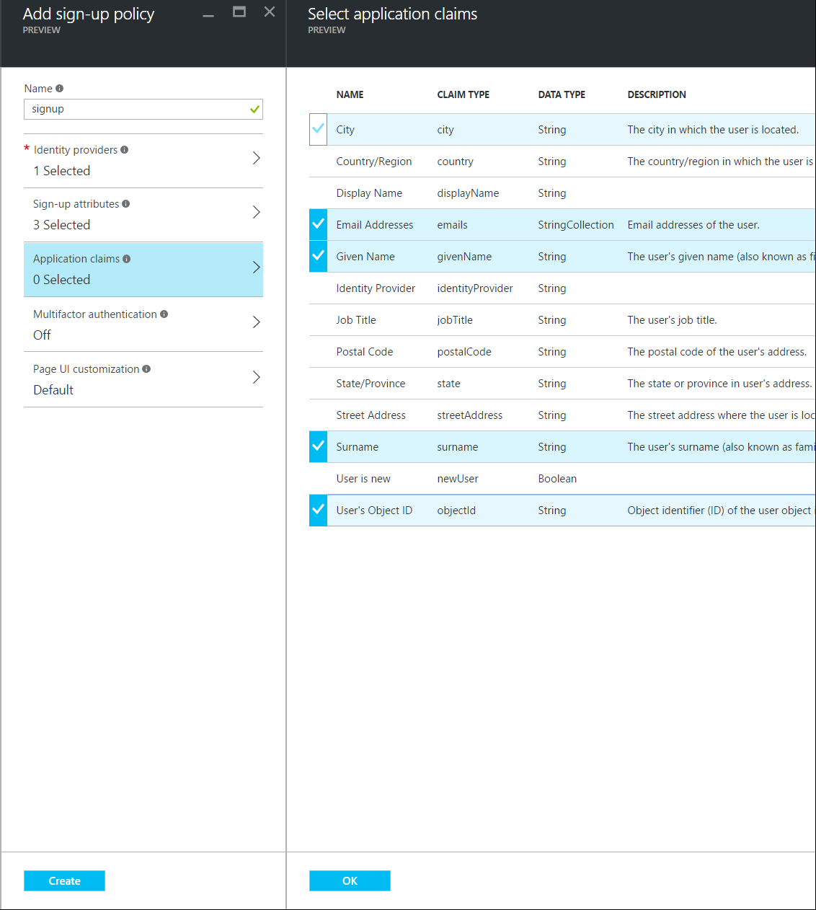

1. Click Create.
2. In the Settings blade, select Sign-in policies.
3. Click + Add.
4. Set the policy name to ‘signin’.

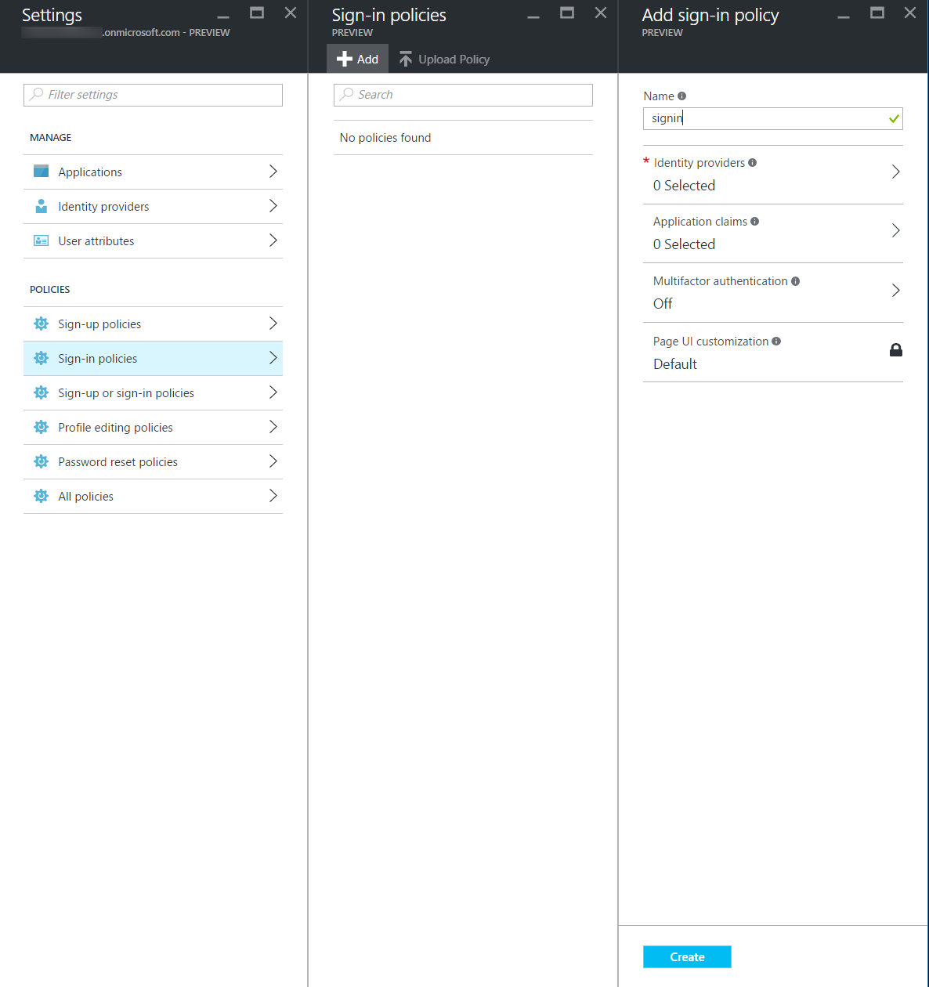

1. Select Identity providers.
2. Select Local Account Signin.
3. Click OK.

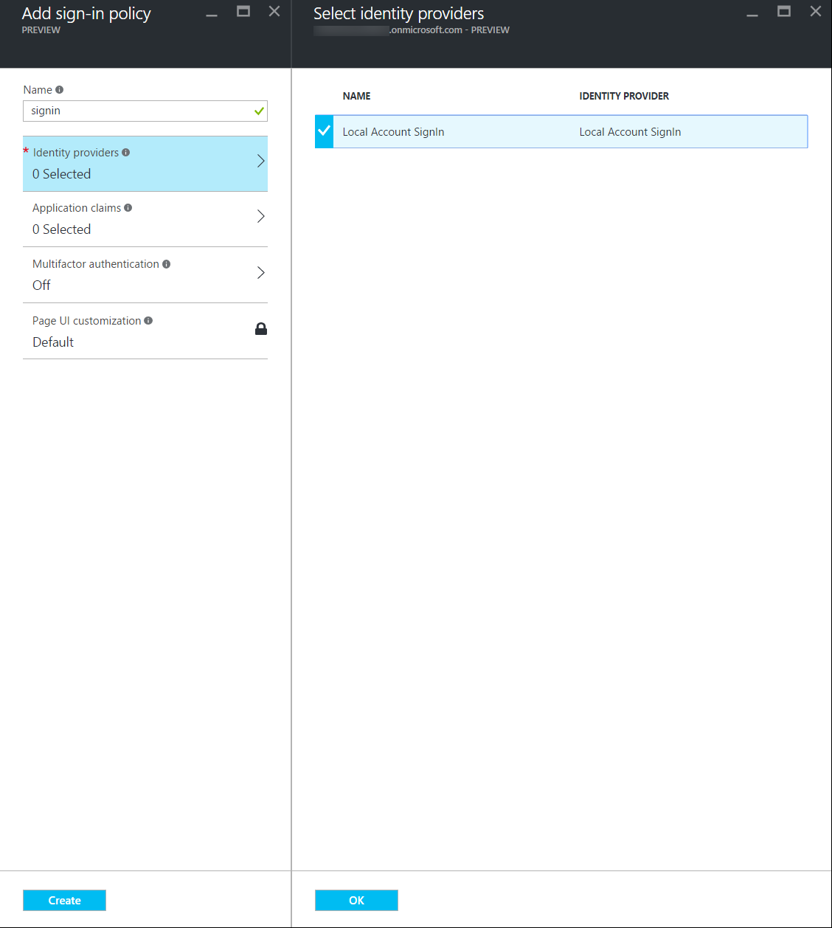

1. Select Application Claims.
2. Select Email Addresses, Given Name, Surname, and User’s Object ID.
3. Click OK.

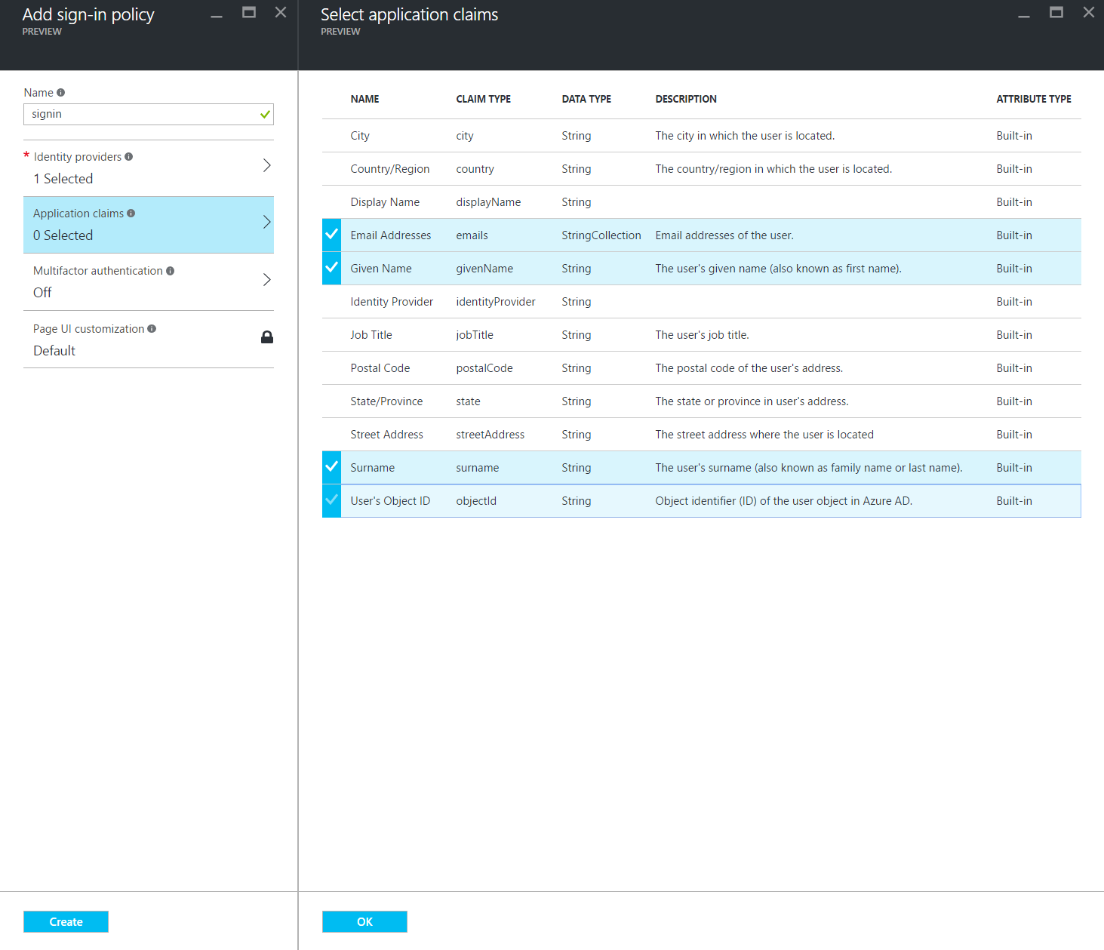

1. Click Create.
2. In the Settings blade, select Profile editing policies.
3. Click + Add.
4. Set the policy name to ‘profileedit’.

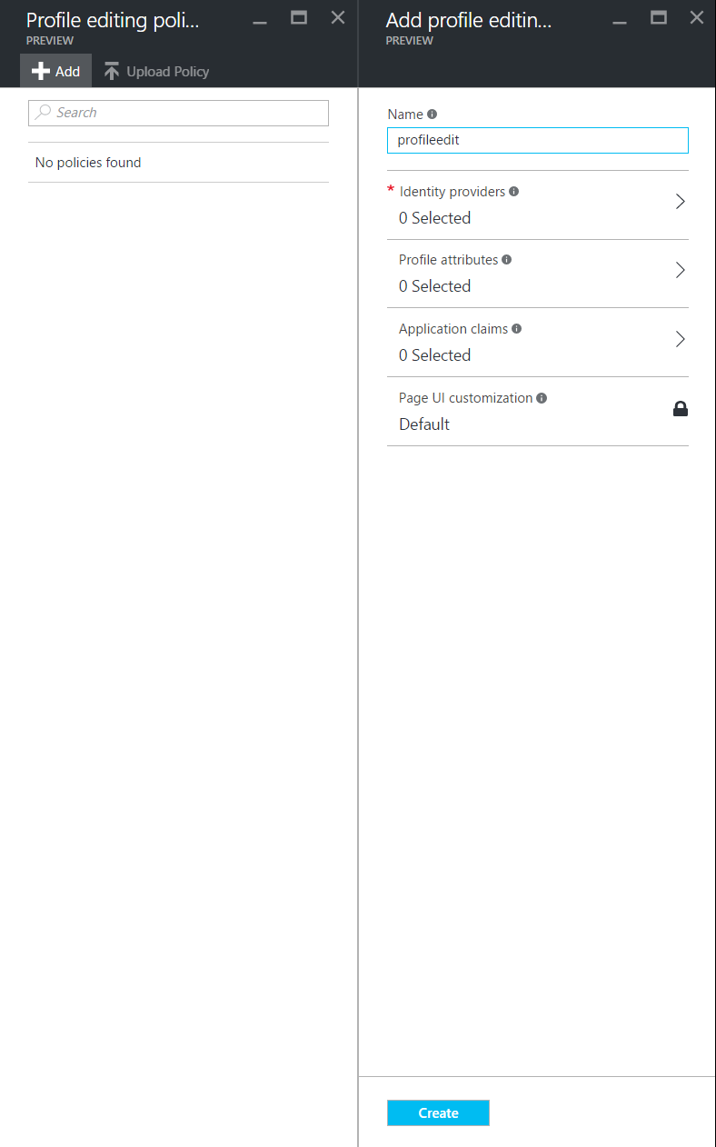

1. Select Identity providers.
2. Select Local Account Signin.
3. Click OK.

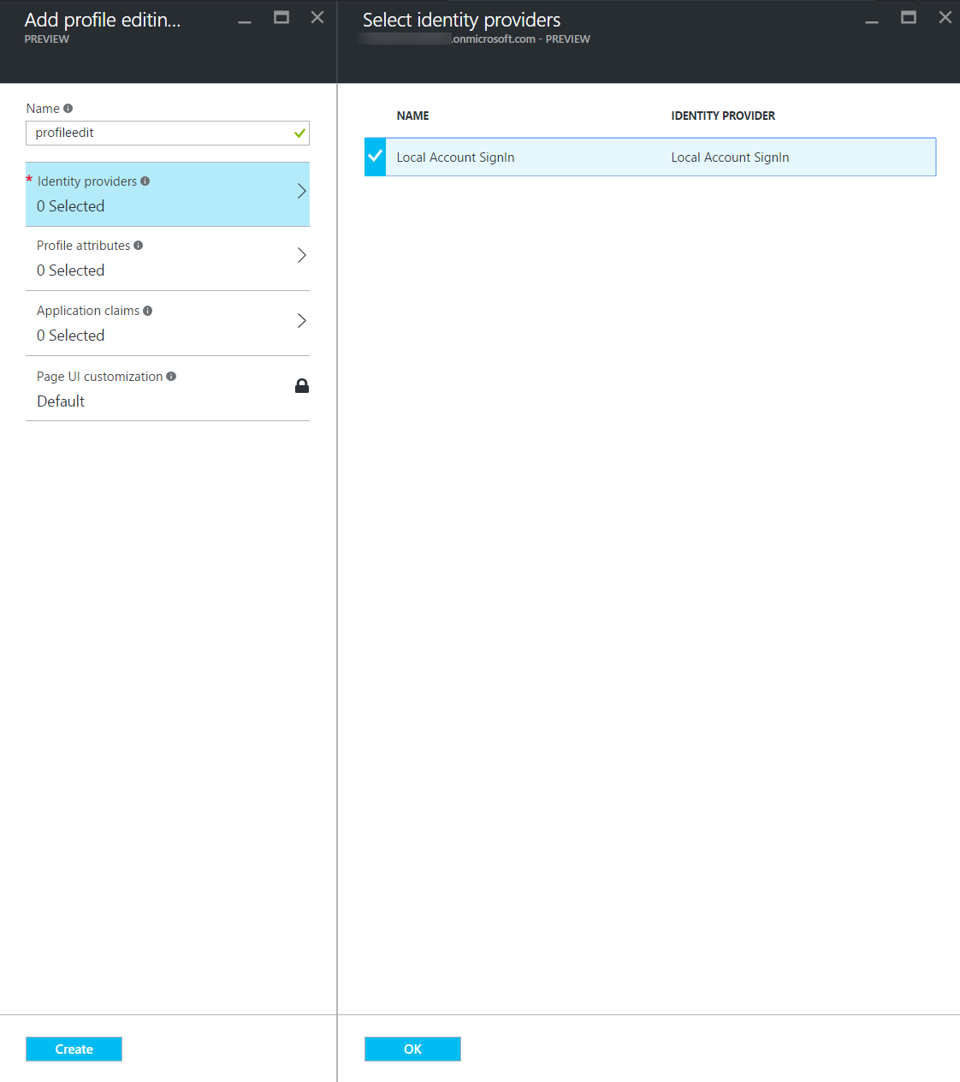

1. Select Profile attributes.
2. Select Given Name and Surname.
3. Click OK.

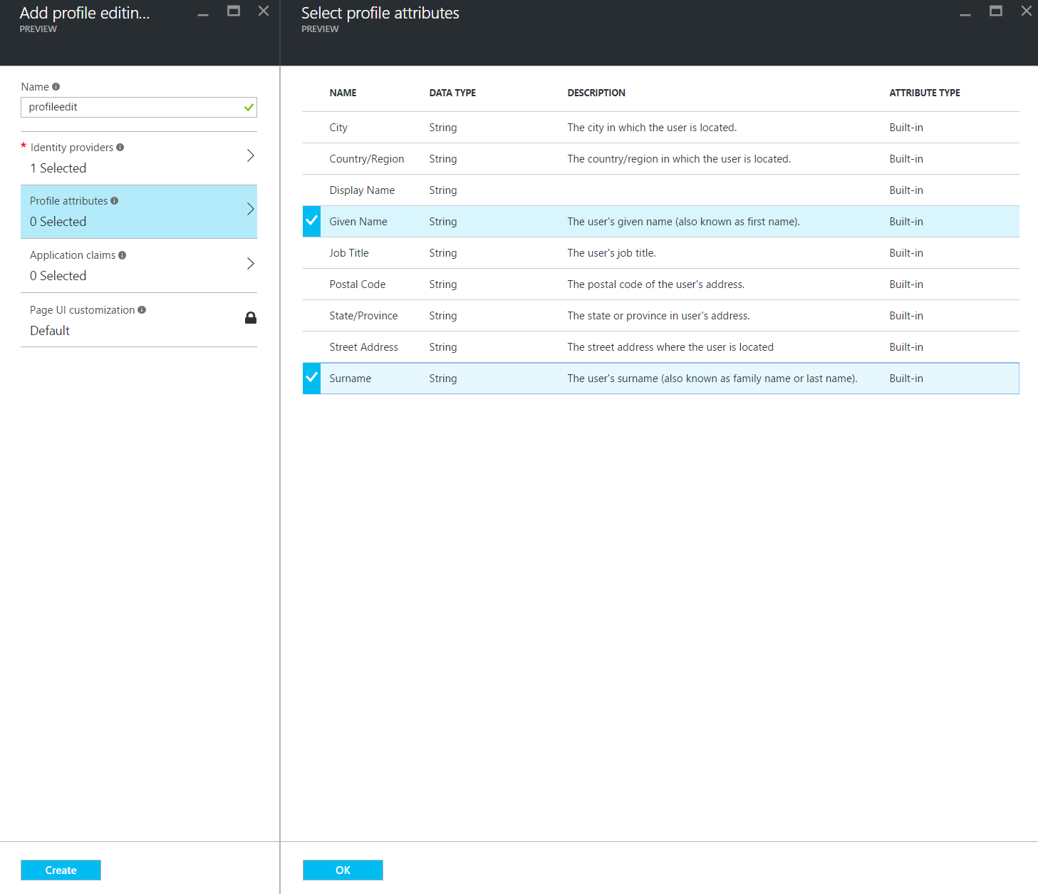

1. Select Application Claims.
2. Select Email Addresses, Given Name, Surname, and User’s Object ID.
3. Click OK.

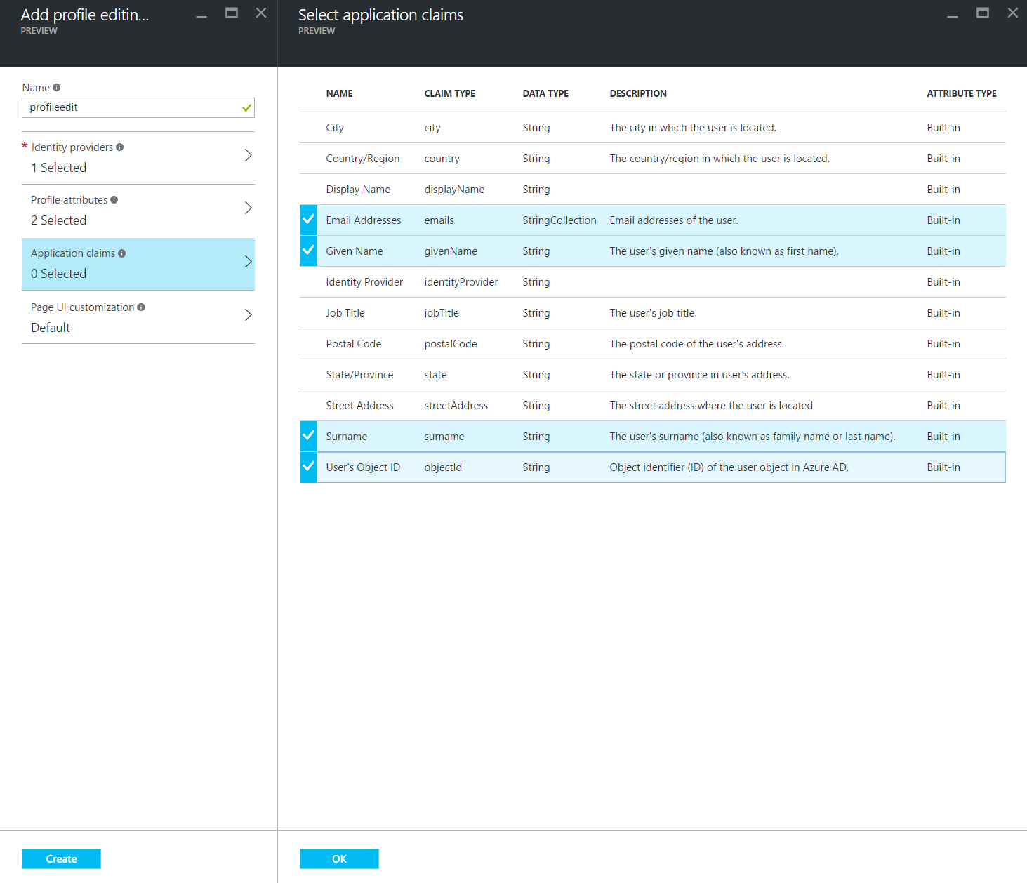

1. Click Create.
2. In the Settings blade, select Applications.
3. Select the created app.
4. Take note of the Application ID as you will need this for the next Task.

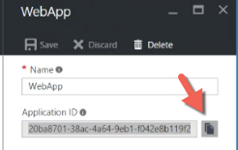

1. In the Settings blade, select All Policies. You should see three policies and the B2C instance. Take note of the names for these policies with the prefix ‘B2C’ as these names will be used in the next task.

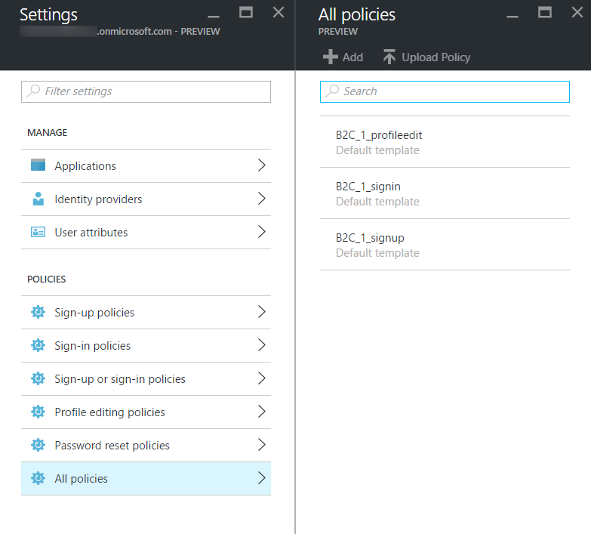

1. Your B2C directory is ready for use and after Task 2 is complete, you will be able to exercise it.

### Task 2: Configure the Web App Settings

In this task, you will update configuration settings in preparation for Azure AD B2C integration.

You will be guided through the instructions to find the information necessary to populate the configuration settings.

1. Within Visual Studio Solution Explorer, expand the Web folder, then expand the ContosoEvents.Web project, and open Web.config. You will update these appSettings in this file:

<add key="ida:Tenant" value="" />

<add key="ida:ClientId" value="" />

<add key="ida:SignUpPolicyId" value="" />

<add key="ida:SignInPolicyId" value="" />

<add key="ida:UserProfilePolicyId" value="" />

#### Azure Active Directory B2C

1. For the ida:Tenant enter the domain of the Azure Active Directory B2C you created such as ‘contosoeventsb2cSUFFIX.onmicrosoft.com’.
2. For the ida:ClientId enter the Application ID generated for your B2C application created in the previous task.
3. For the ida:SignUpPolicyId enter the name of the sign-up policy you created in the tenant (e.g., B2C_1_signup).
4. For the ida:SignInPolicyId enter the name of the sign in policy you created in the tenant (e.g., B2C_1_signin).
5. For the ida:UserProfilePolicyId enter the name of the profile editing policy you created in the tenant (e.g., B2C_1_profileedit).

### Task 3: Add security features to the Web application

In this task, you will enable security features that will leverage the configuration you just applied.

1. From Solution Explorer, expand the Web site folder ContosoEvents.Web.
2. Open Startup.cs in the root folder and uncomment the line of code below the TODO item. This will set up the authentication middleware so that users are redirected to authenticate to Azure AD B2C when they access protected resources.

//TODO Exercise 10 - Task 3

ConfigureAuth(app);

1. Open FilterConfig.cs from the App_Start folder, and uncomment the line below the TODO item. This will provide default protection for all routes so that authentication is required unless the route allows anonymous callers.

//TODO Exercise 10 - Task 3

filters.Add(new Policies.PolicyAuthorize { Policy = Startup.SignInPolicyId });

1. Open _Layout.cshtml under Views\Shared and remove the 3 lines following the TODO item, and uncomment area below it. This will prevent the menu items to be hidden unless the user is authenticated. It will look like this when you complete the change.

@*TODO Exercise 10 - Task 3 *@

@if (Request.IsAuthenticated)

{

<li><a href="@Url.Action("Index", "Orders")"><span class="glyphicon glyphicon-shopping-cart"></span> Orders</a></li>

<li><a href="@Url.Action("Index", "LoadTest")"><span class="glyphicon glyphicon-flash"></span> LoadTest</a></li>

<li><a href="@Url.Action("Status", "LoadTest")"><span class="glyphicon glyphicon-stats"></span> LoadTest Status</a></li>

}

1. Open _LoginPartial.cshtml under Views\Shared and uncomment the area below the TODO item. This will enable the menus for user sign in and sign out.

@*TODO Exercise 10 - Task 3 *@

@if (

Request.IsAuthenticated)

{

<text>

<ul class="nav navbar-nav navbar-right">

<li>

<a id="profile-link"><span class="glyphicon glyphicon-user"></span> @User.Identity.Name</a>

<div id="profile-options" class="nav navbar-nav navbar-right">

<ul class="profile-links">

<li class="profile-link">

<a href="@Url.Action("Profile", "Account")"><span class="glyphicon glyphicon-pencil"></span> Edit Profile</a>

</li>

</ul>

</div>

</li>

<li>

<a href="@Url.Action("SignOut", "Account")"><span class="glyphicon glyphicon-log-out"></span> Sign out</a>

</li>

</ul>

</text>

}

else

{

<ul class="nav navbar-nav navbar-right">

<li><a id="signUpLink" href="@Url.Action("SignUp", "Account")"><span class="glyphicon glyphicon-user"></span> Sign up</a></li>

<li><a id="loginLink" href="@Url.Action("SignIn", "Account")"><span class="glyphicon glyphicon-log-in"></span> Sign in</a></li>

</ul>

}

1. Compile the application and ensure no errors before the next step.

### Task 4: Running the Web App and signing in

In this task, you will test the web application and register yourself as a user to log in to the Azure AD B2C tenant.

1. Using Solution Explorer in Visual Studio, open the Web folder.
2. Right click the ContosoEvents.Web project, select Debug, and then Start new instance.
3. When the application launches you will see the web site home page.

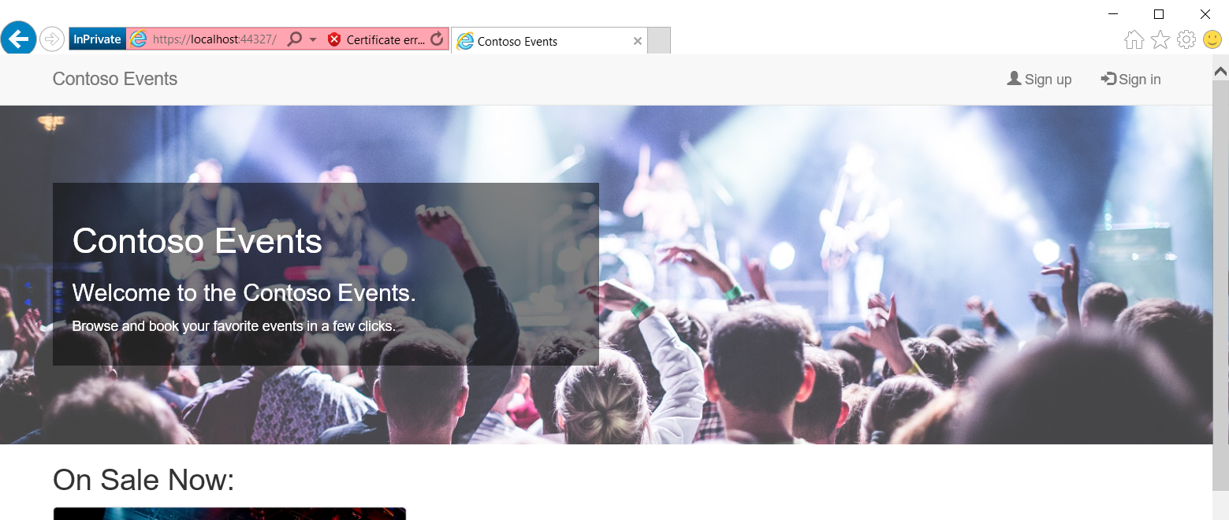

1. Click Sign up and complete a new user registration. After that, you will be returned to the web site. Note that your username is shown in the menu bar.

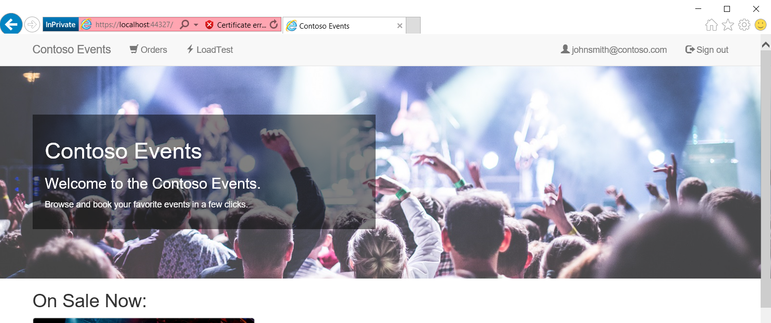

1. You will be redirected back to the web app.
2. You can now sign in, sign out, and register users to the web site.

**Note**: You can optionally publish this application to Azure and test sign in, sign out continues to work from the deployed URL.

## Exercise 11: Cleanup

Duration: 10 minutes

In this exercise, attendees will de-provision any Azure resources that were created in support of the lab.

#### Tasks to complete

1. Go to the Azure Portal and select your subscription.
2. Navigate to the Function App your created (e.g., contosoeventsfn-SUFFIX).
3. Select ProcessOrderExternalizations, and the Manage.
4. Click Delete on the Manage pane to delete this function.
5. Repeat steps 3-4 for the Function ProcessSimulationRequests.
6. Find the Resource Group you created for this exercise.

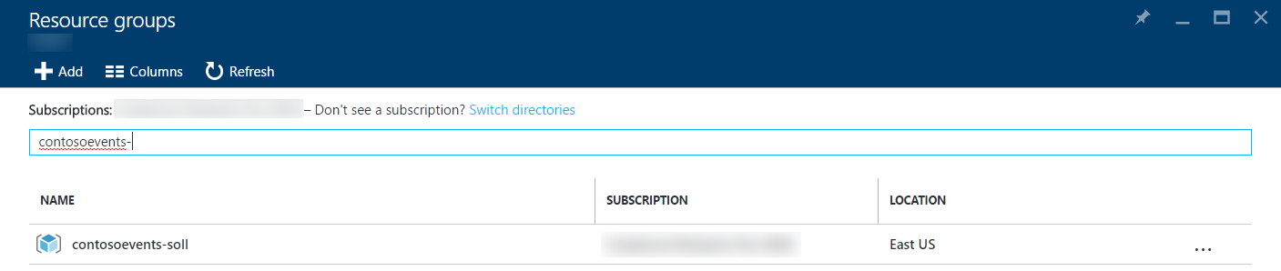

1. Select the Resource Group to delete.
2. Click the Delete menu from the resource blade.

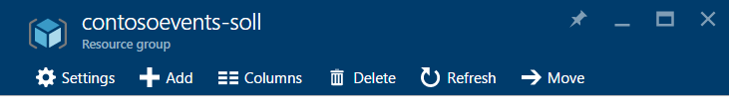

1. In the delete confirmation blade, type the Resource Group name and click Delete. You will be able to see all of the resources allocated to the group before you confirm.

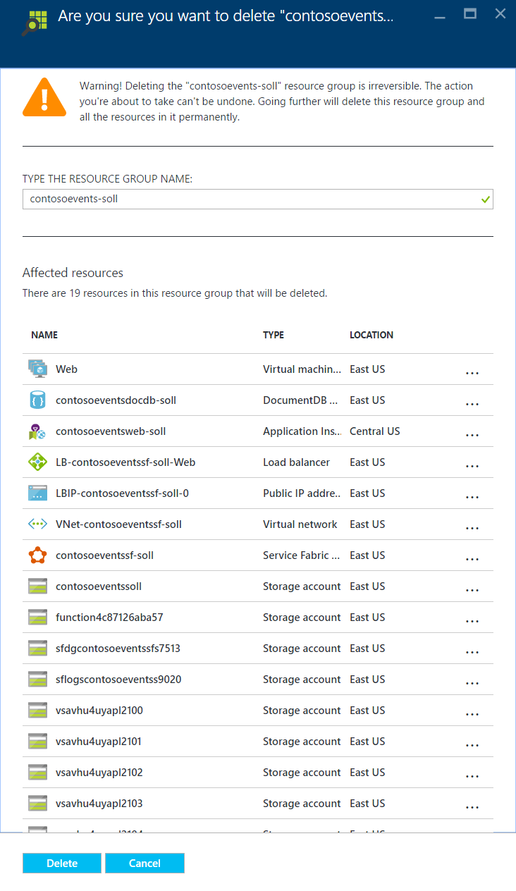

1. In the Management Portal, from the left menu, select Active Directory.



11. Select the tenant to delete and delete it.

After all of the deletion tasks are complete, the resources will no longer be listed in the Azure Portal or the Management Portal. This may take about 10 minutes. You can optionally wait to see a confirmation. Otherwise, you are done!